**1.Converting JSON file to CSV file**

**2.Copying CSV File to SQL Data base**

**3.Copying JSON File to another BLOB Storage**

**4.Delete JSON File from Source Blob**

**Storage account:** It contains all of your Azure Storage data objects, including blobs, file shares, queues, tables, and disks. The storage account provides a unique namespace for your Azure Storage data that's accessible from anywhere in the world over HTTP or HTTPS. Data in your storage account is durable and highly available, secure, and massively scalable.

There are four types of storages: Blob Storage, Queue Storage, Table Storage, and Azure Files

**Containers:** A container organizes a set of blobs, similar to a directory in a file system. A storage account can include an unlimited number of containers, and a container can store an unlimited number of blobs.

**Datasets:** Datasets are simply points or reference the data, which we want to use in our activities as input or output

**Linked services:** Linked services are used to connect to other sources with the Azure data factory. Linked services act as connection strings for resources to connect.

**Pipelines:** Pipeline is a logical grouping of activities that together perform a task. The following diagram shows the relationship between pipelines, activity and dataset.

**1.Converting JSON file to CSV file**

* For Converting JSON File to CSV File we need storage account
* The Creation of Storage account is shown Below figure

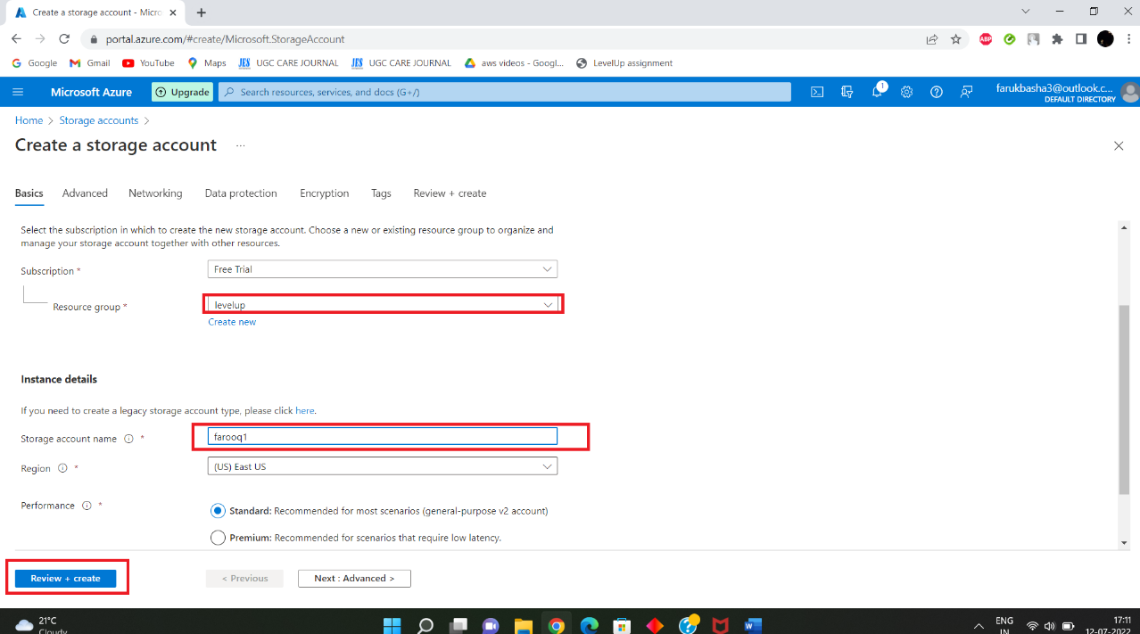

* Select resource group if your already created otherwise Create New
* Next Give any Storage account name uniquely(Because it saves globally )
* Next Click on Review+ Create

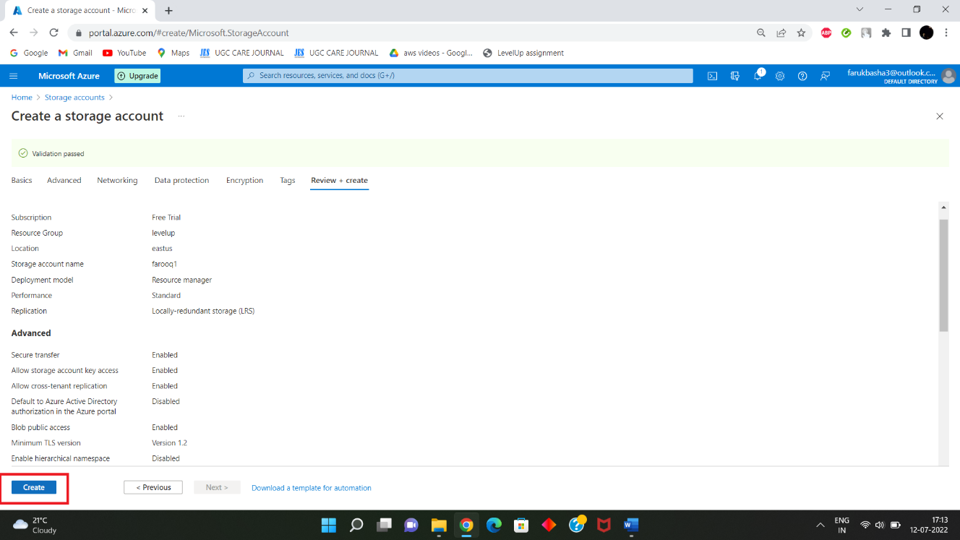

* After validation passed click on create

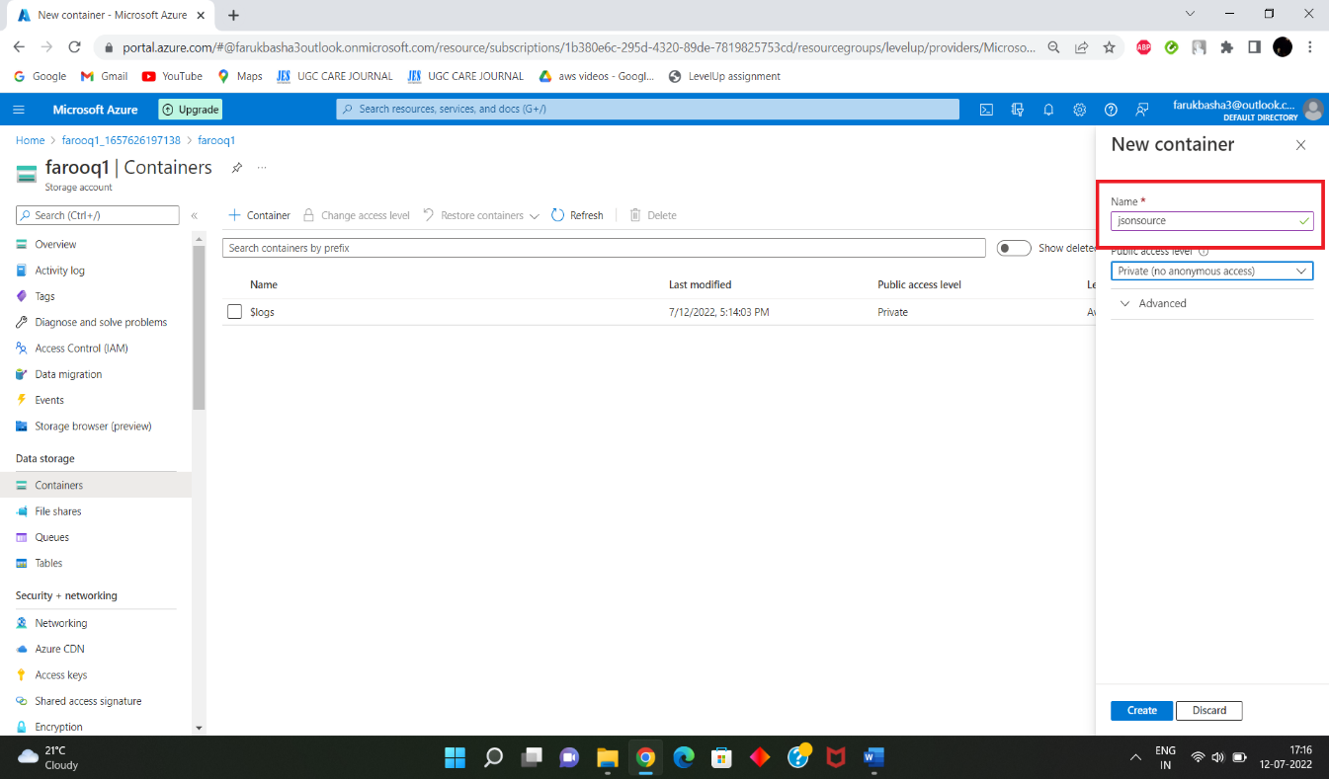

* In the storage account click on new container give container w and create

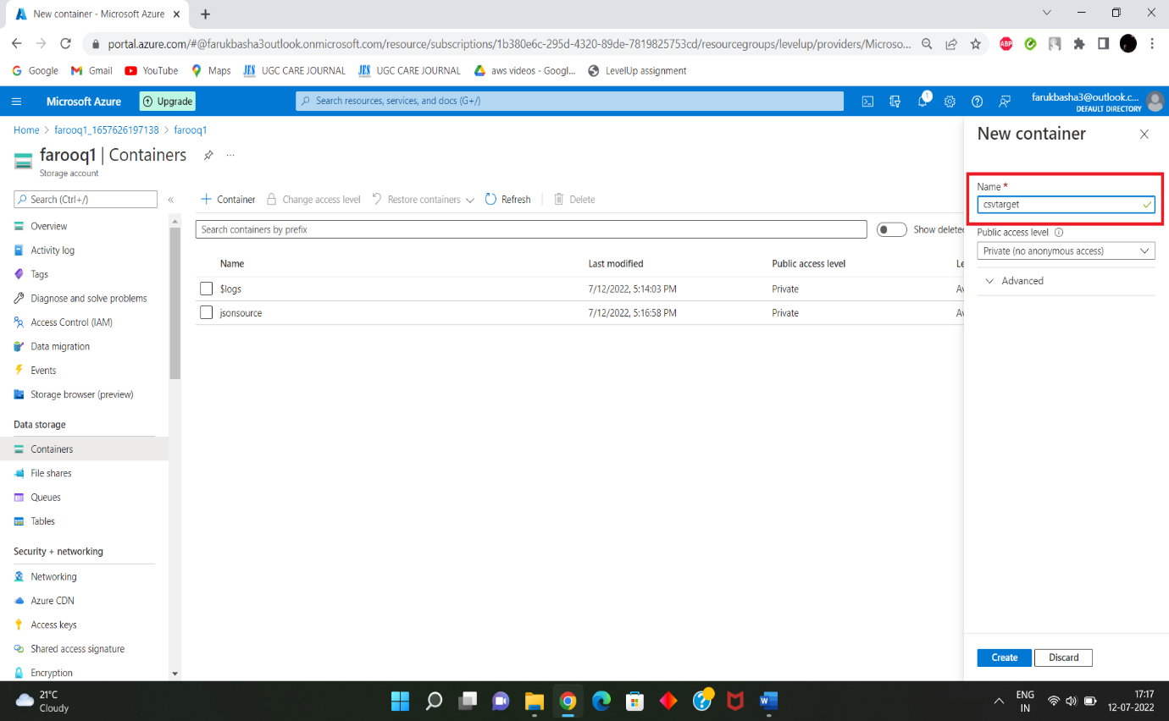

* Create another container which represents as target

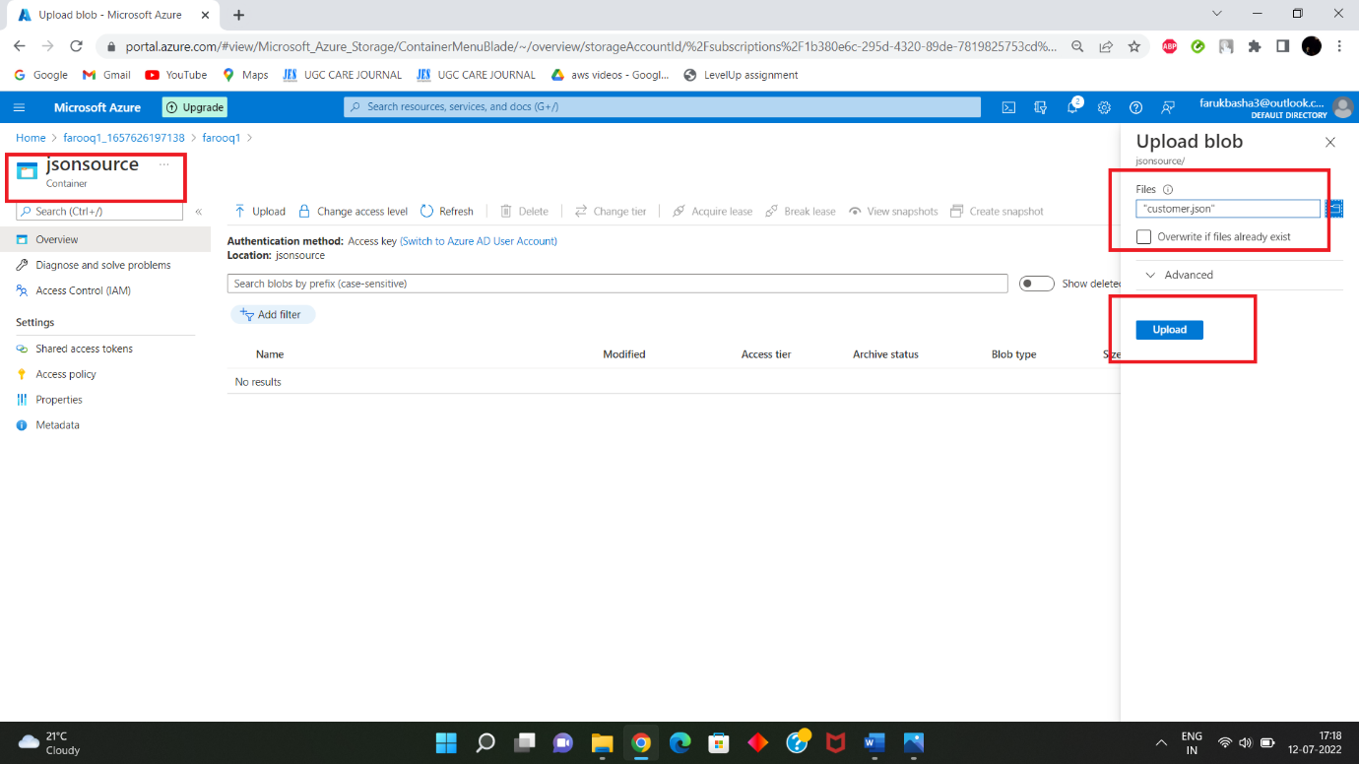

* In source container (I named as jsonsource) need to upload a JSON file

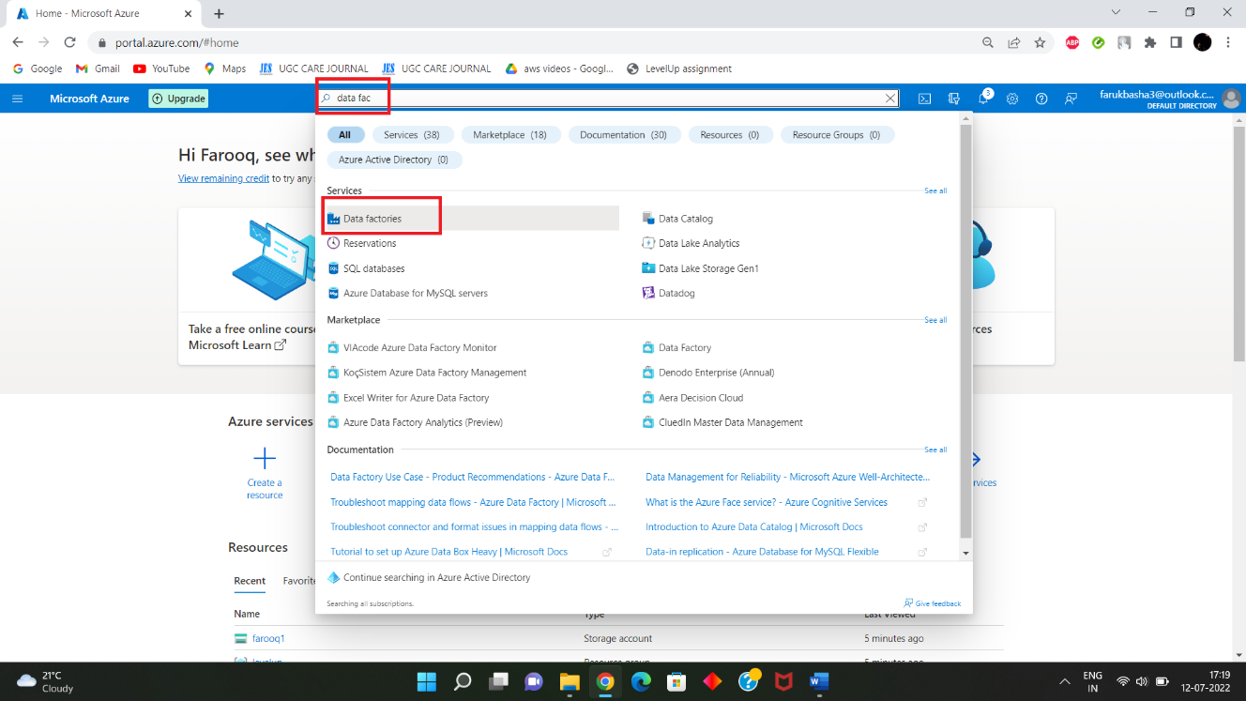

* After creation of Storage account search data factory as shown in above figure

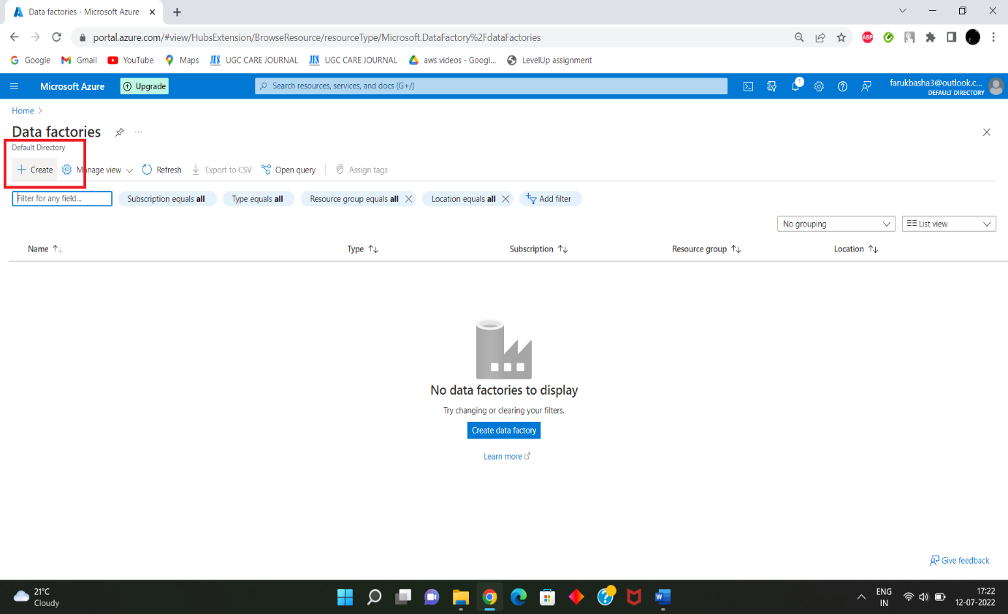

* In the Data factories Click on Create

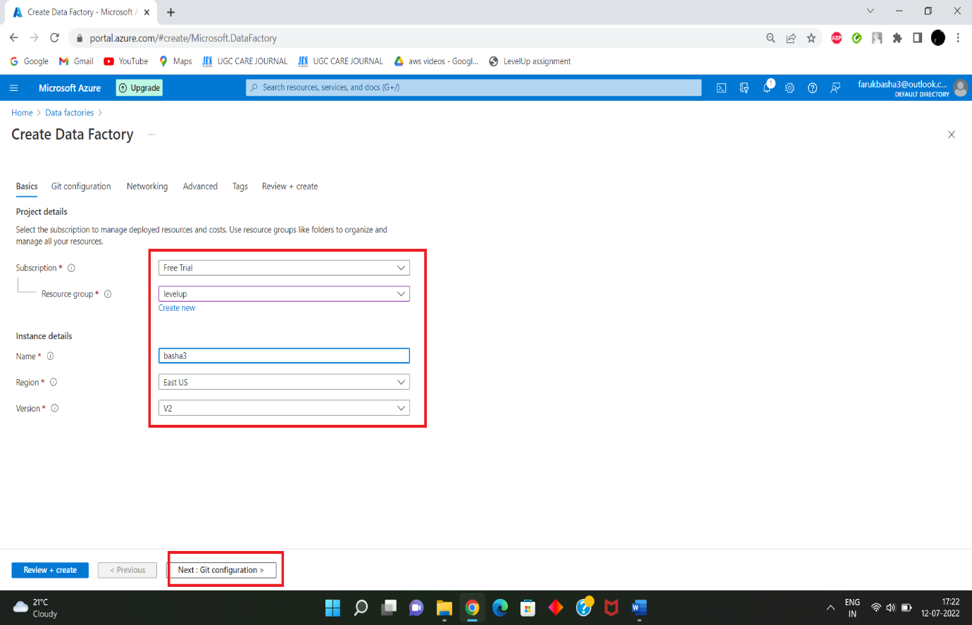

* Next Fill the above all fields as your requirements
* Next Click on Git Configuration

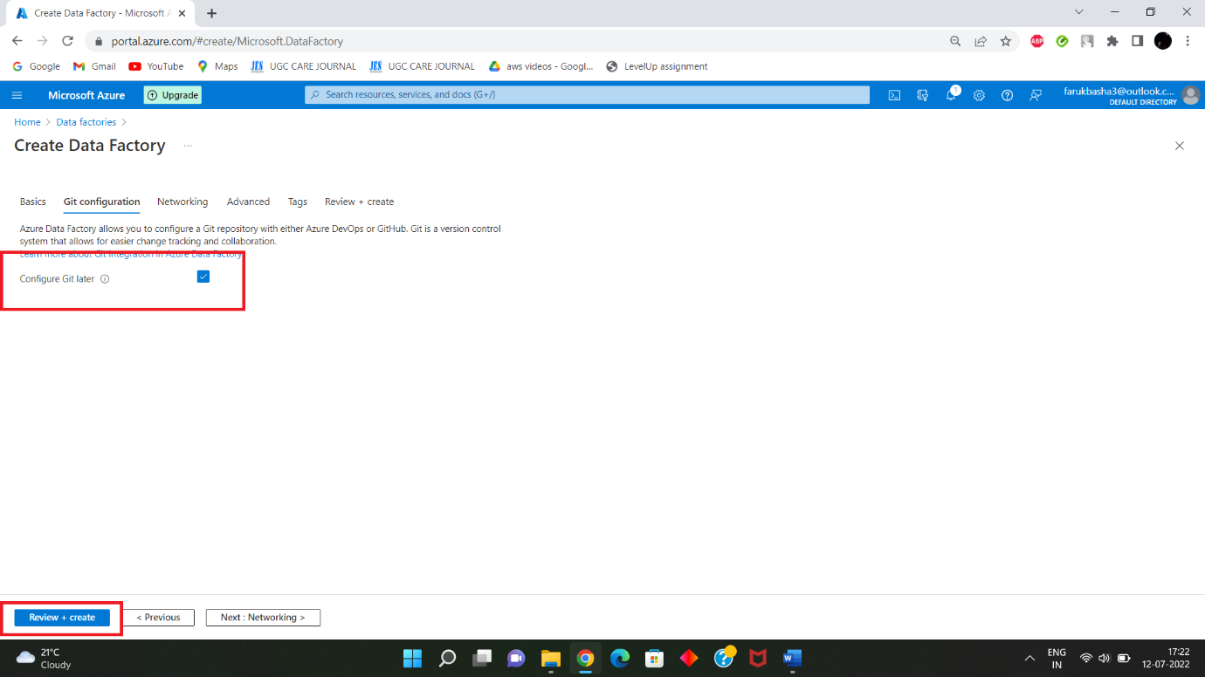

* Select Configure git later and Click on Review + create

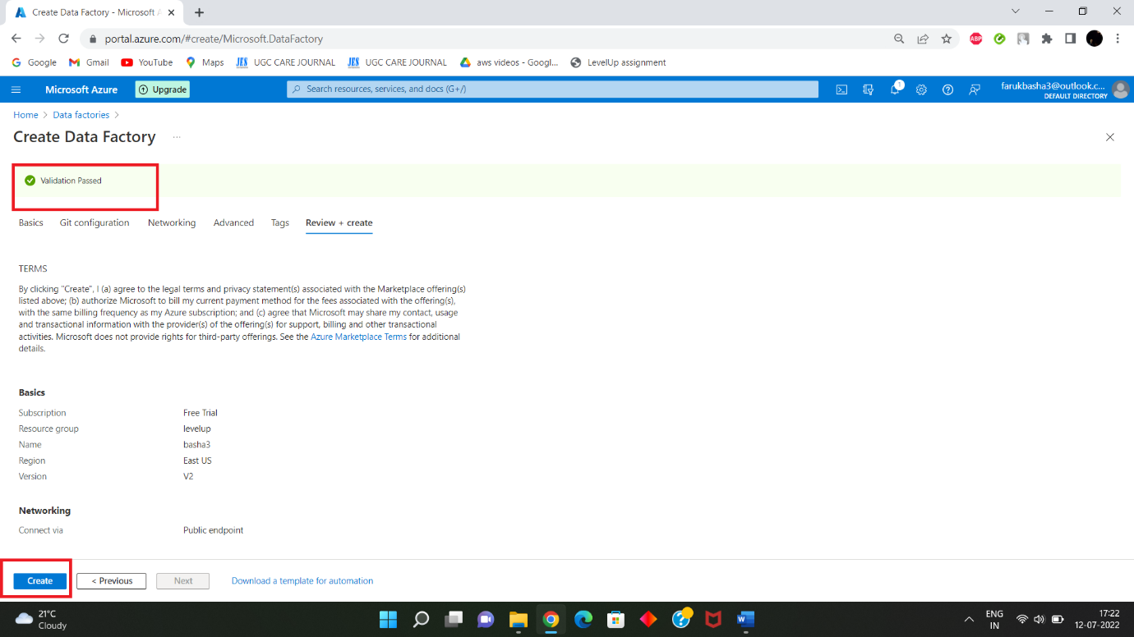

* After Validation passed Click on Create

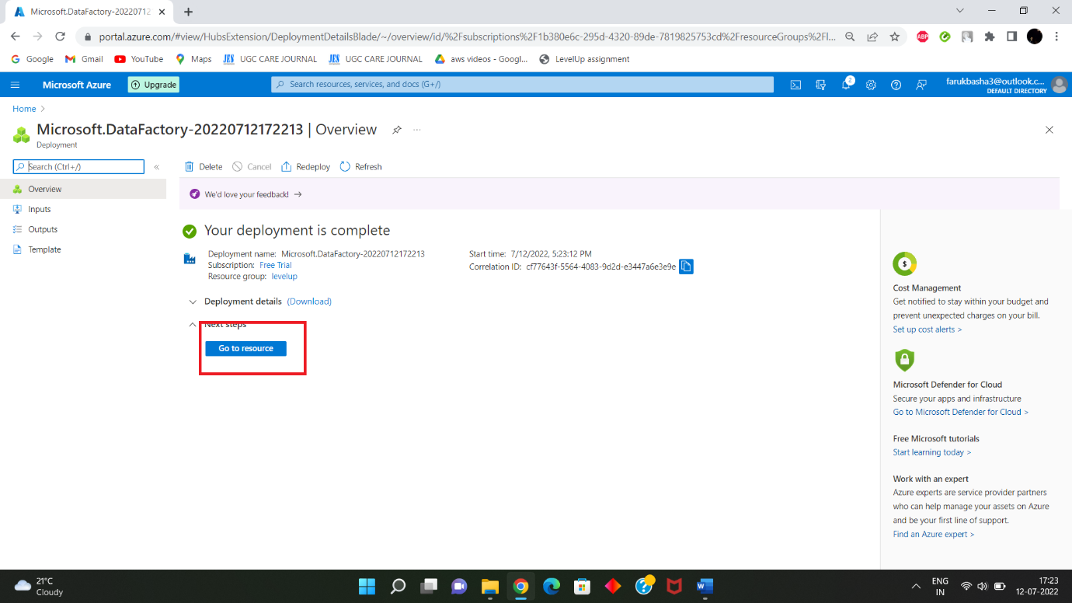

* Go to Resource

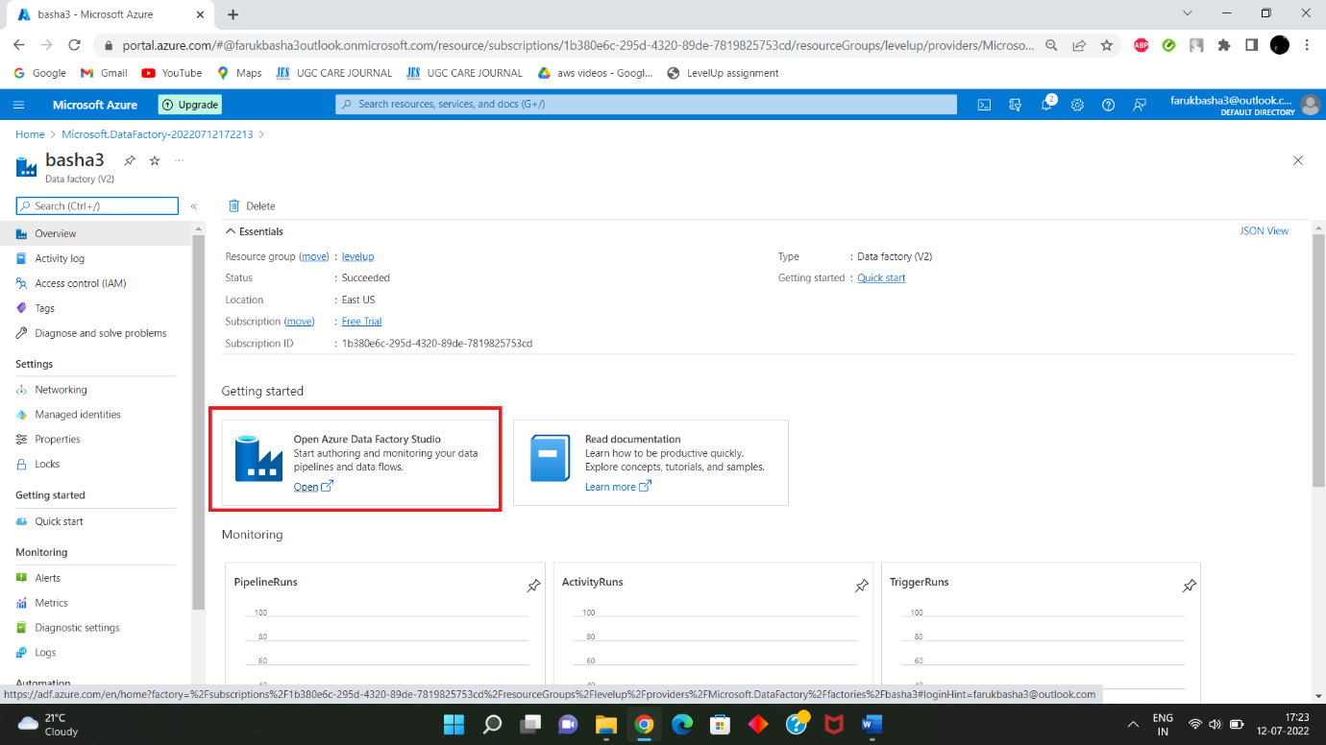

* When clicking on resource the page appears like above figure
* In this page click on Open Azure Data Factory Studio

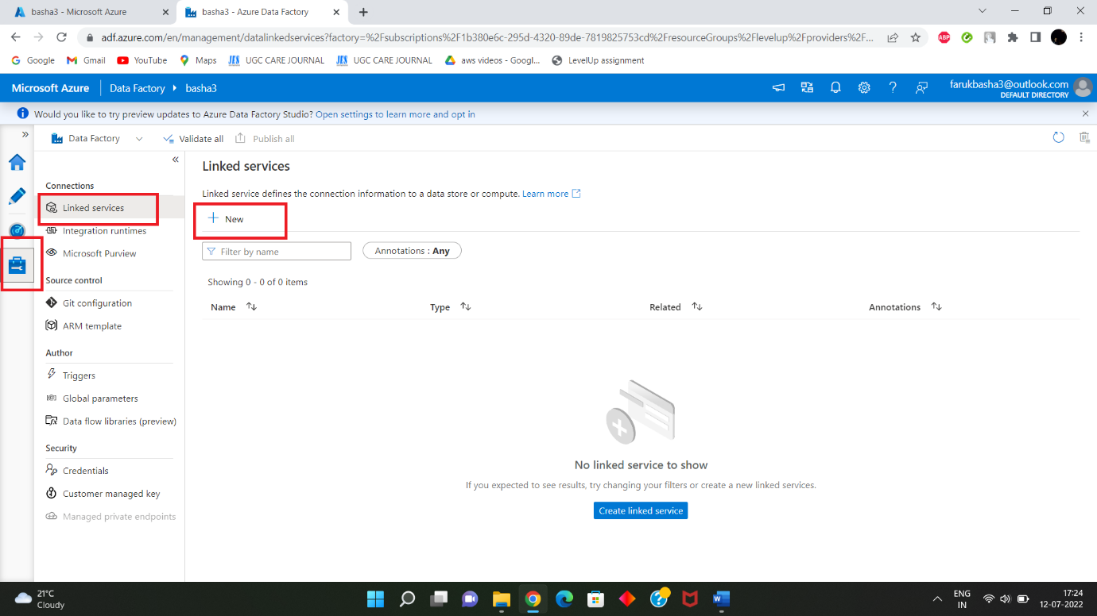

* When you open ADF in the left side you can see Home, Author, Monitor, Manage.
* In the Manage Click on Linked services
* After that Click on New

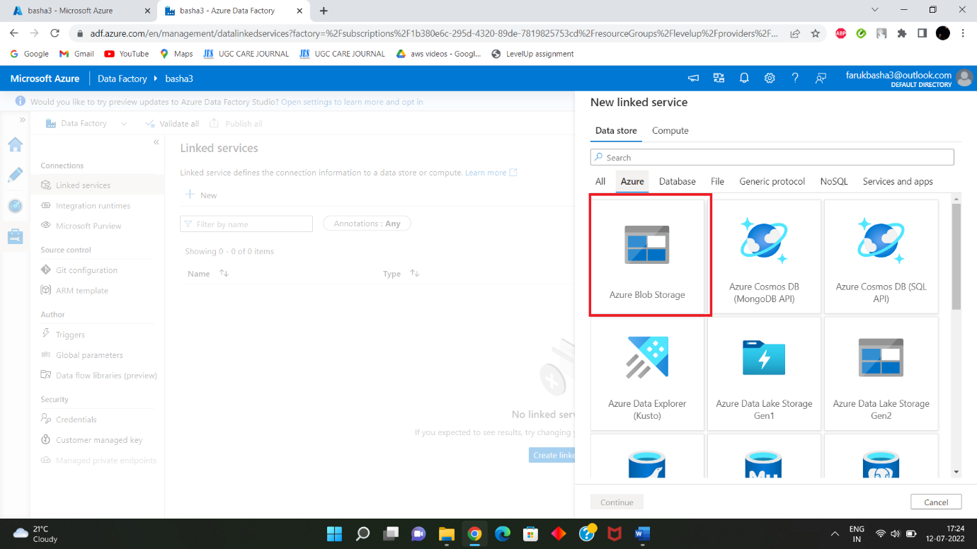

* After clicking on New it shows All Data Stores in that we have to select Azure blob storage because we are converting JSON File to CSV file that all stores in blob storage

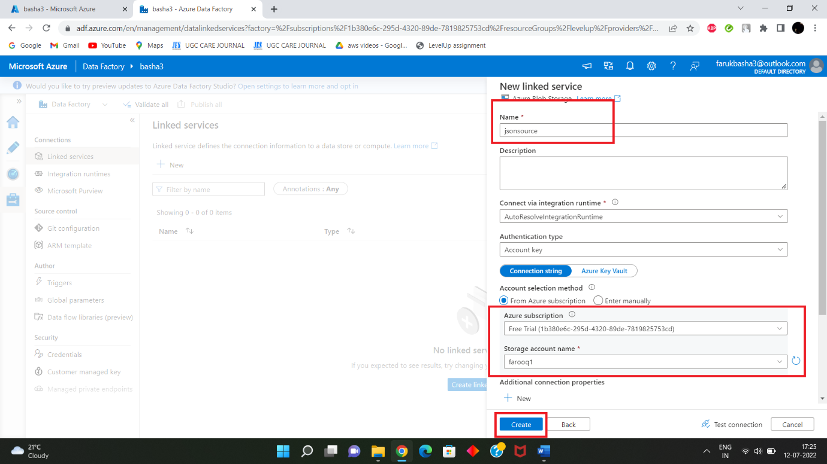

* Give a name as you can remember
* Next select Azure subscription and storage account name and click on create

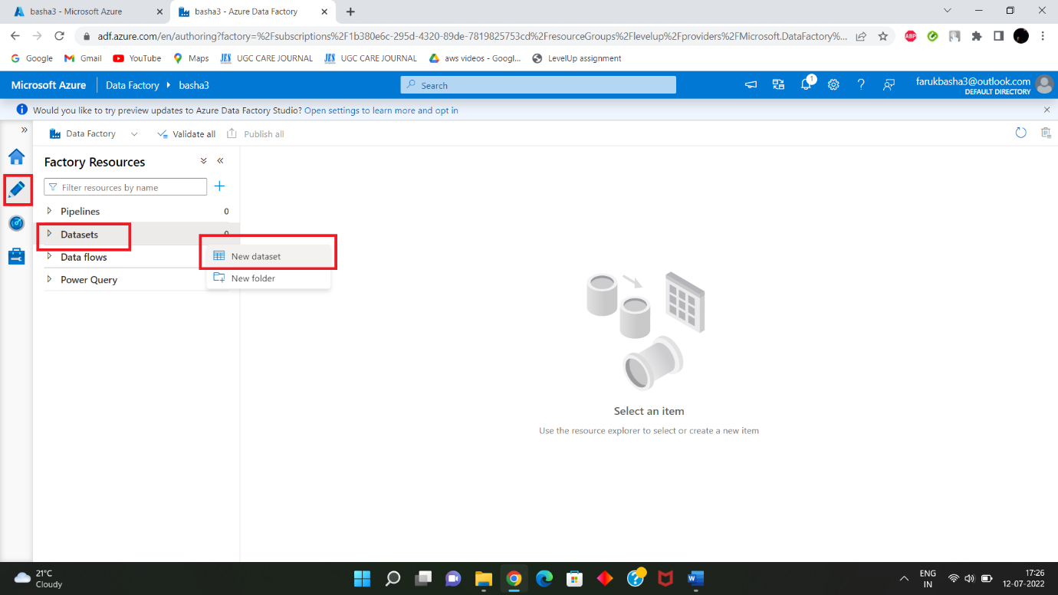

* After the creation of Linked service, go to Author in that you can see Datasets
* Create one Dataset

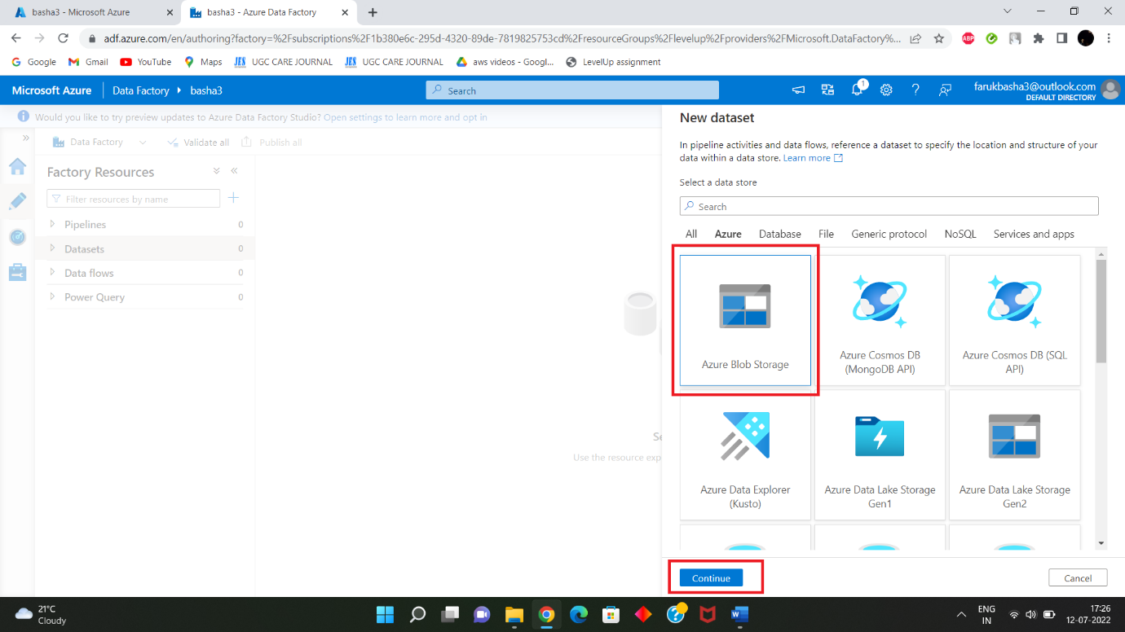

* Click on Azure blob storage and continue

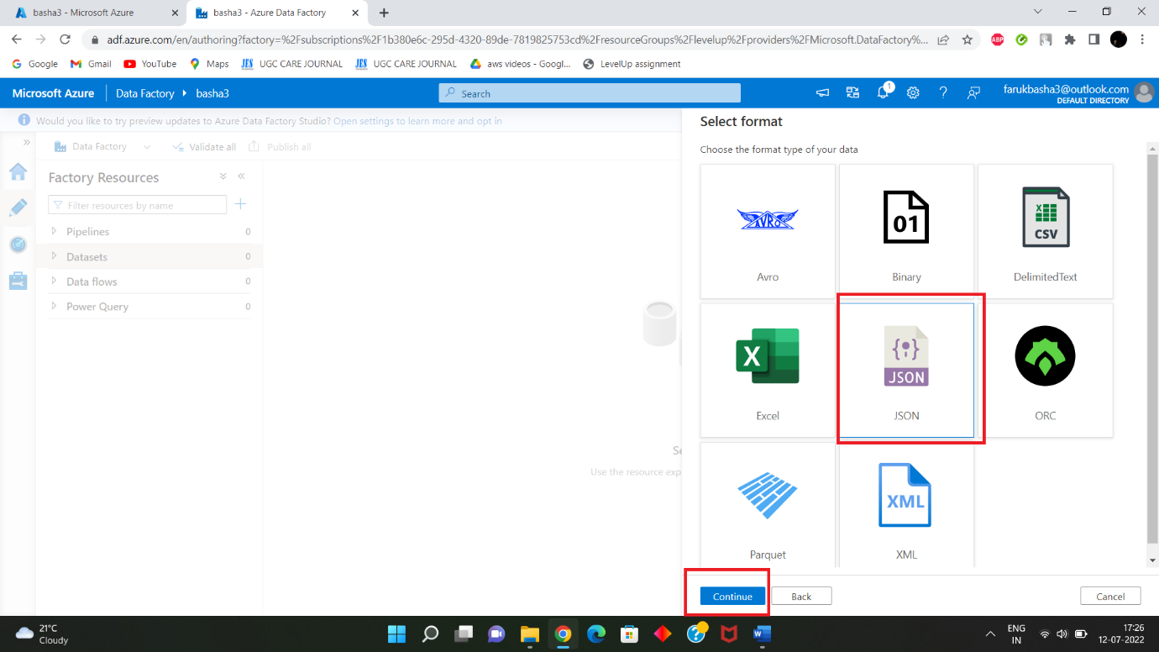

* In that Click On JSON because the file format is JSON and click Continue

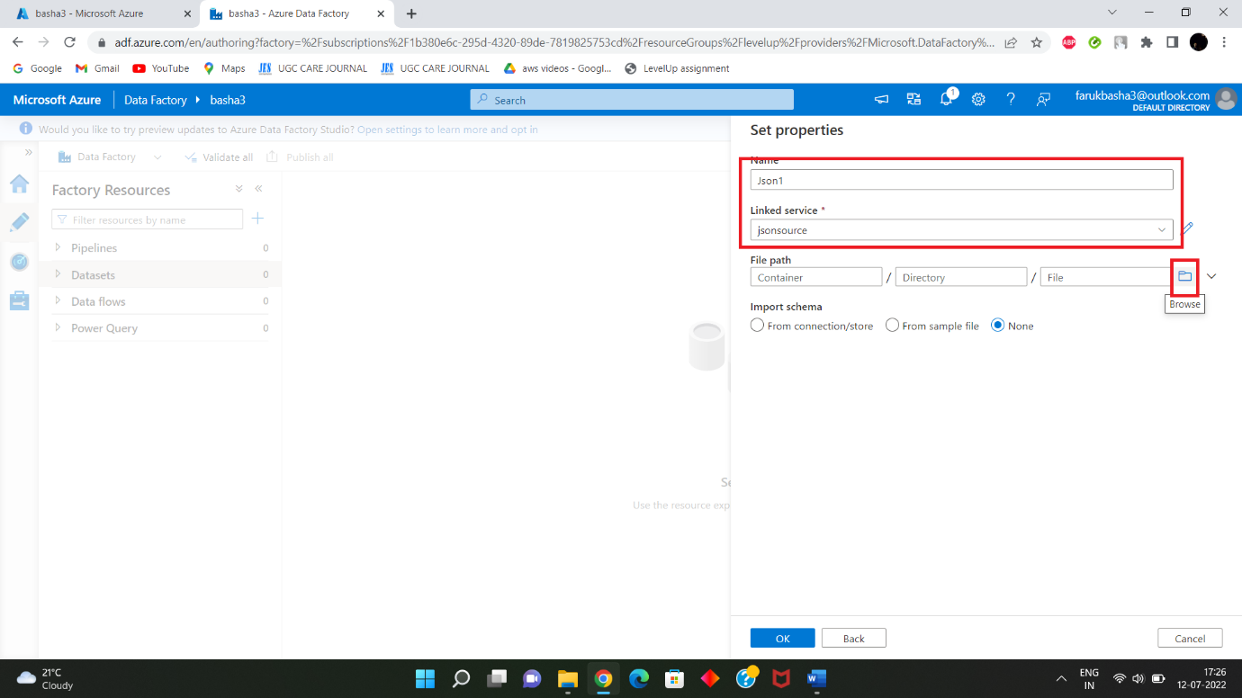

* Here Give Name and Linked service and click on Browse

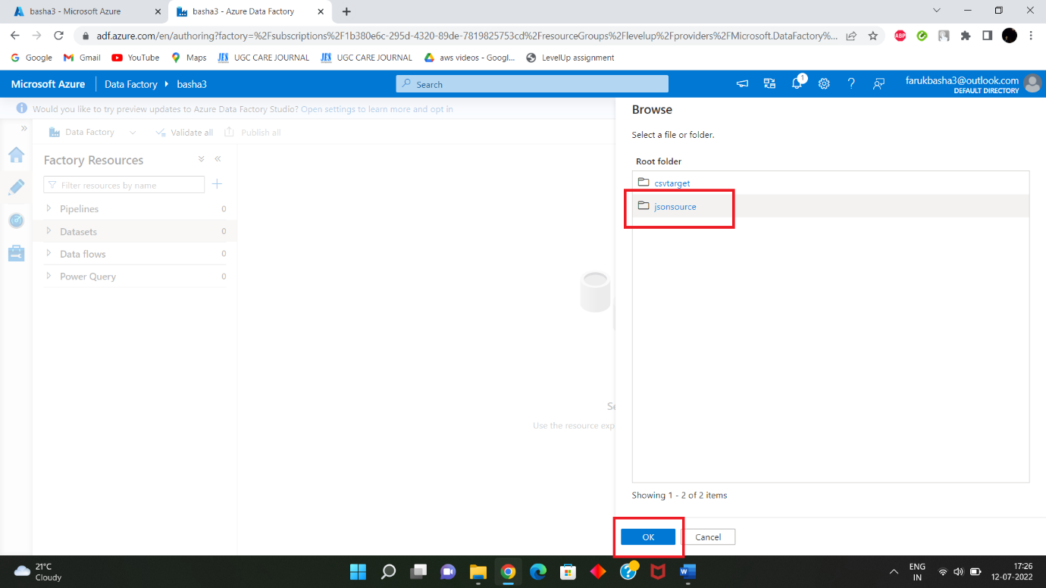

* In the Browse Select joinsource(My container Name)

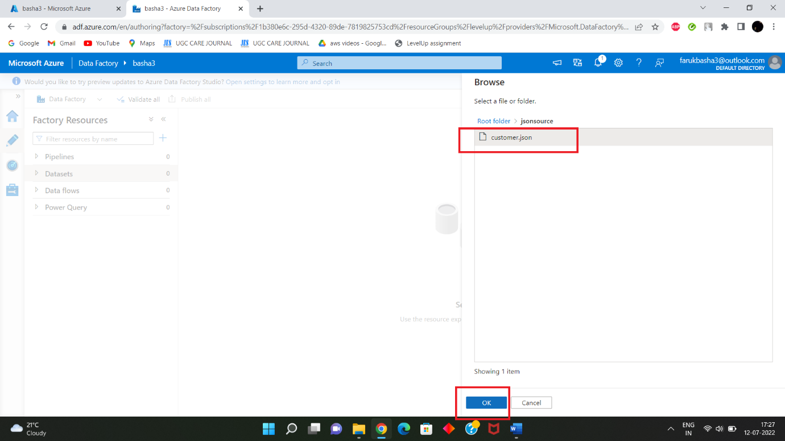

* In the container we have a file Named as customer.json and click on ok

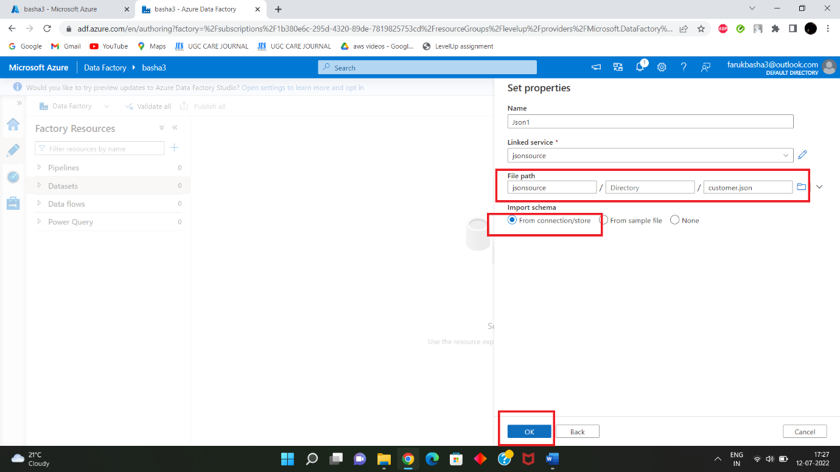

* After selecting file, the path will set select as it is like showing in above figure

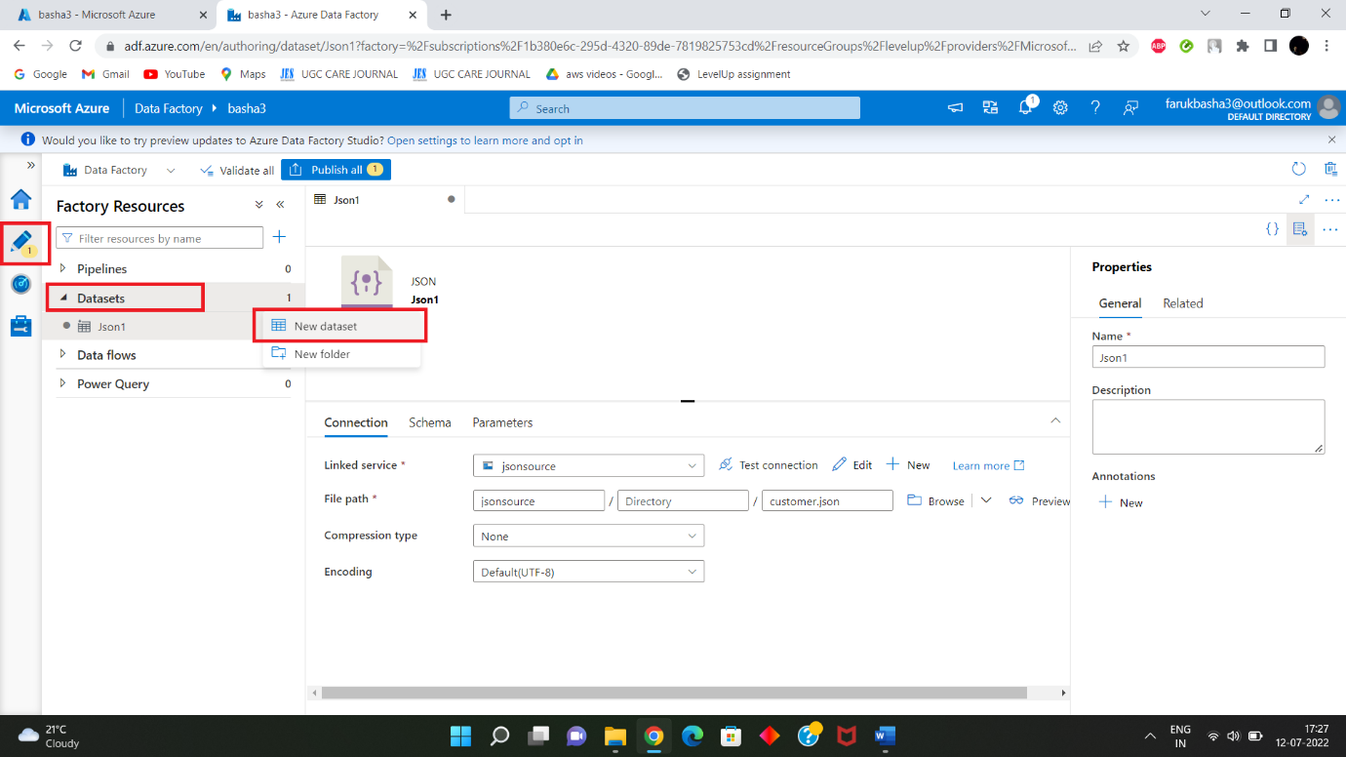

* Next, we need to create another dataset for another container
* Go to Author, Right Click on Dataset and create new Dataset

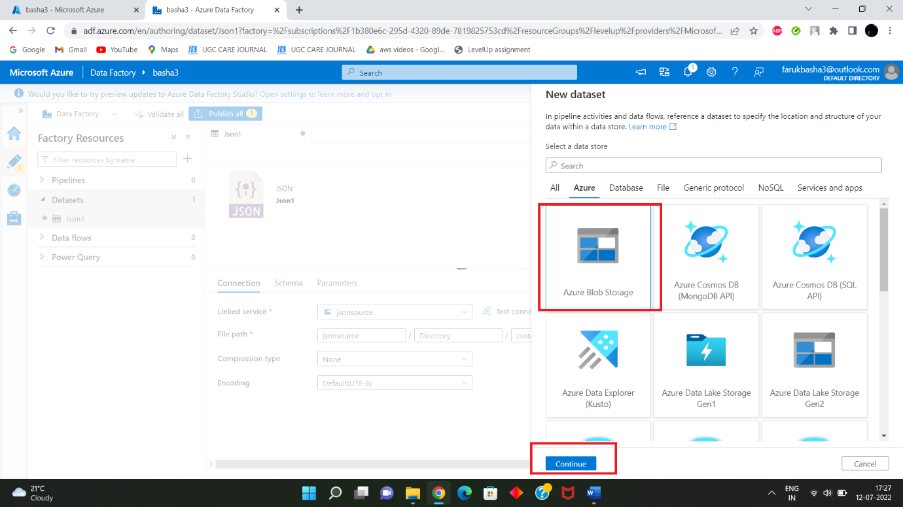

* After clicking On New dataset, it shows all data stores
* Click on Azure Blob Storage and continue

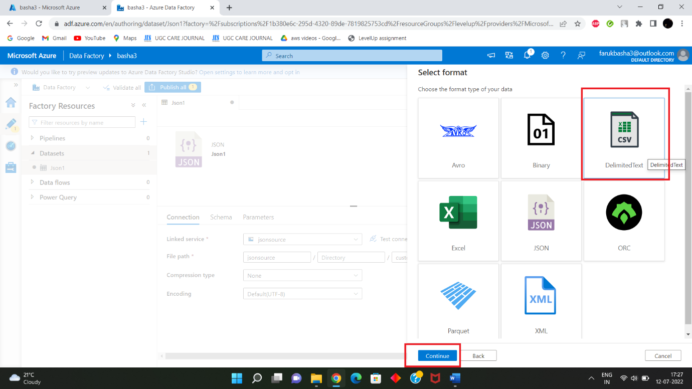

* Here we have to select Delimited text (CSV) because we are converting JSON to CSV right so here, we have to select this

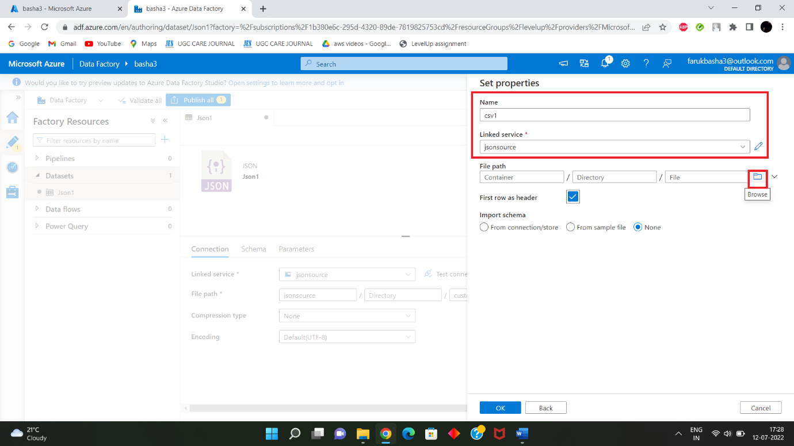

* In the properties Set Name and Link the Linked Service and click on Browse

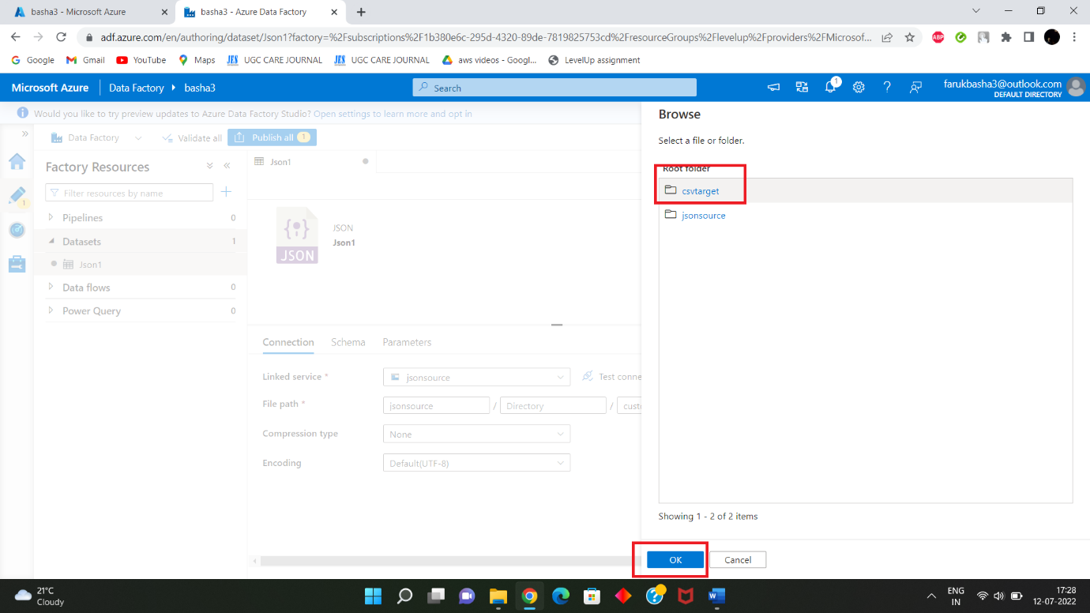

* In the browse section Select the csvtarget (target folder) and click on ok

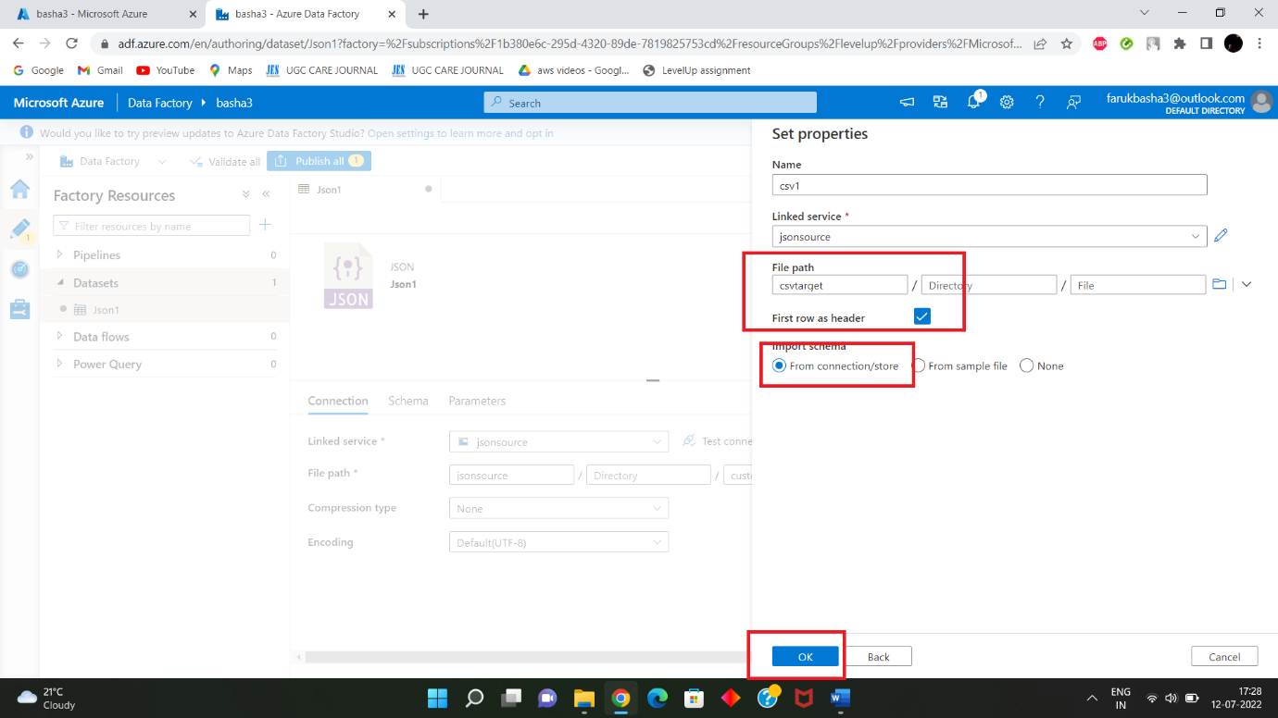

* The path will set and select First row as header
* Click on Import schema as it shown in above figure, and click on ok

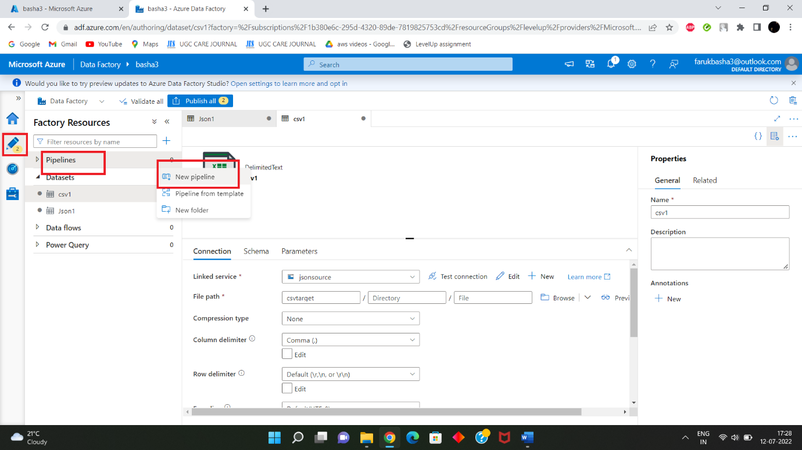

* After Creating Datasets create New Pipeline
* Click on New Pipeline

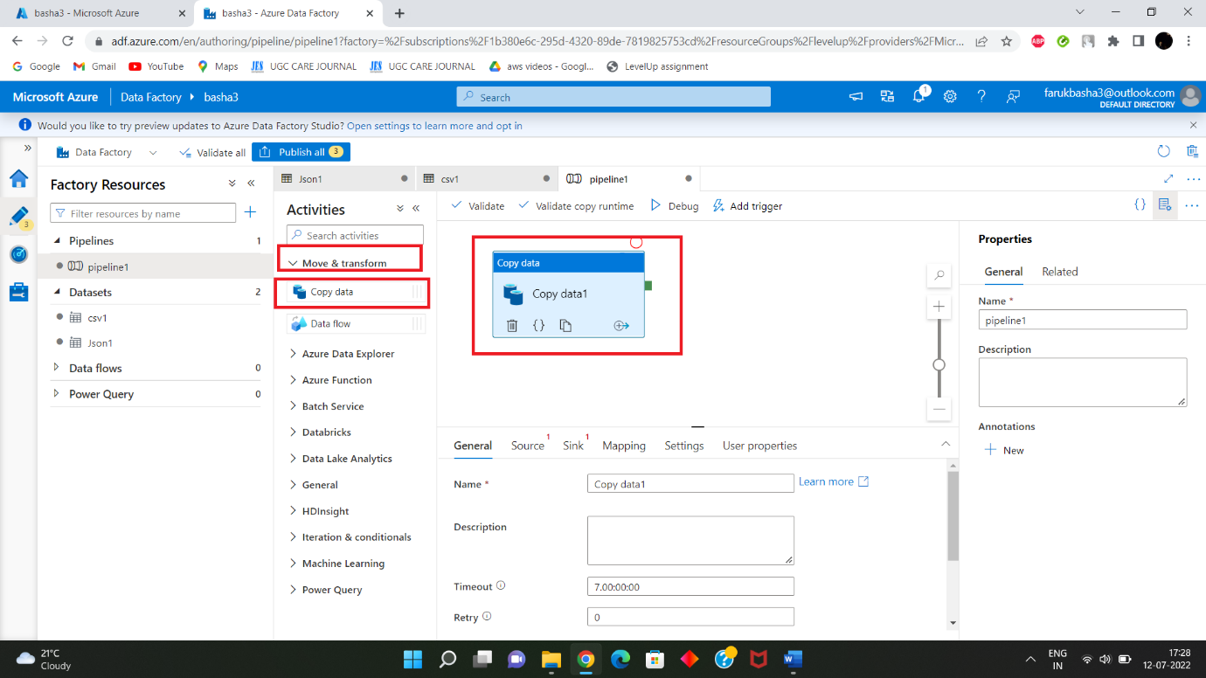

* In the Pipeline you can see Move & Transform click on that you can see Copy data
* Drag that copy data to behind open area

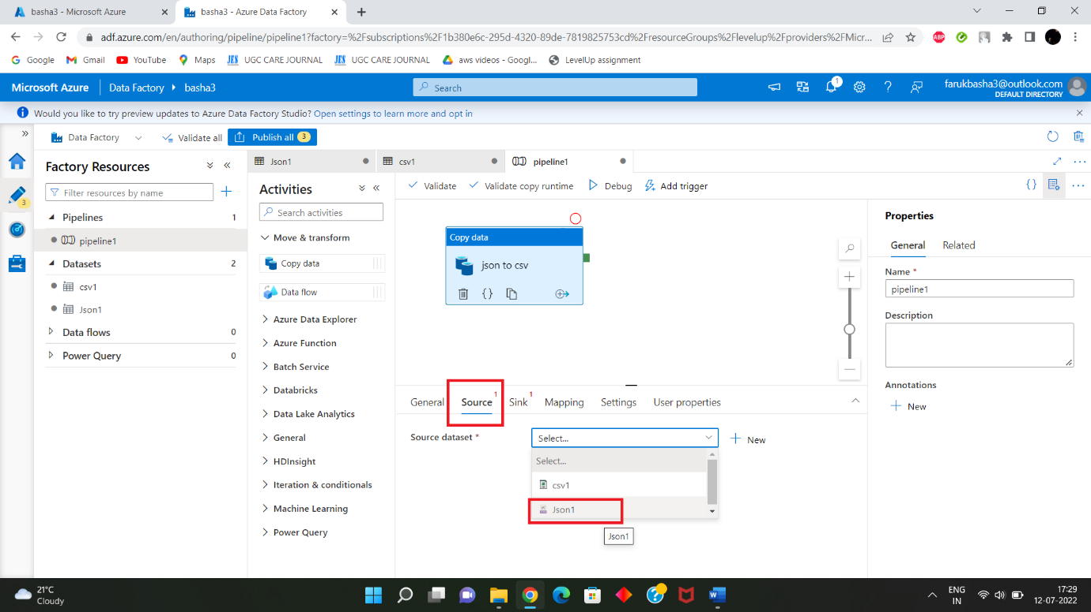

* After that Click on Source and Select Dataset which represents Source file

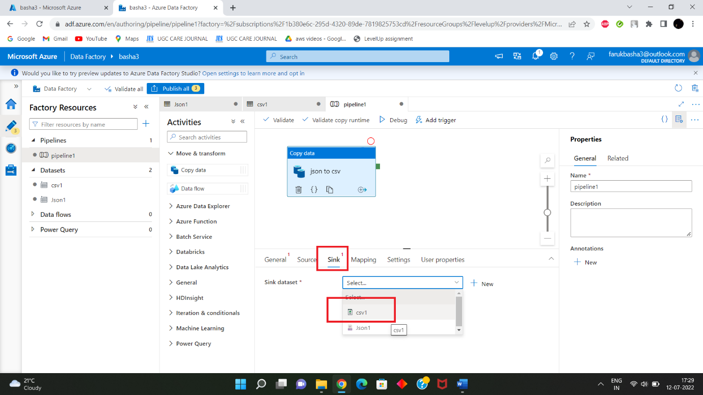

* Next click on sink in that select Target Dataset

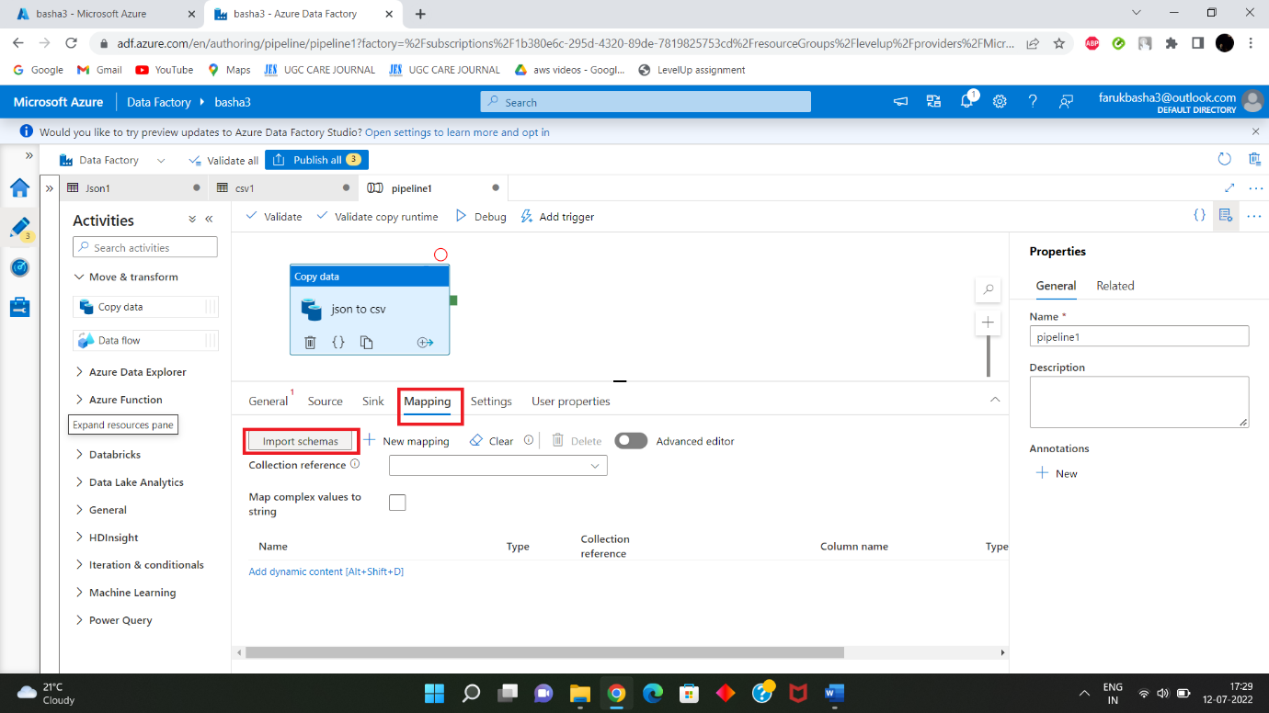

* Here we can see something called Mapping
* Mapping means here we can change Column names and Data types
* For that Click on Import Schemas

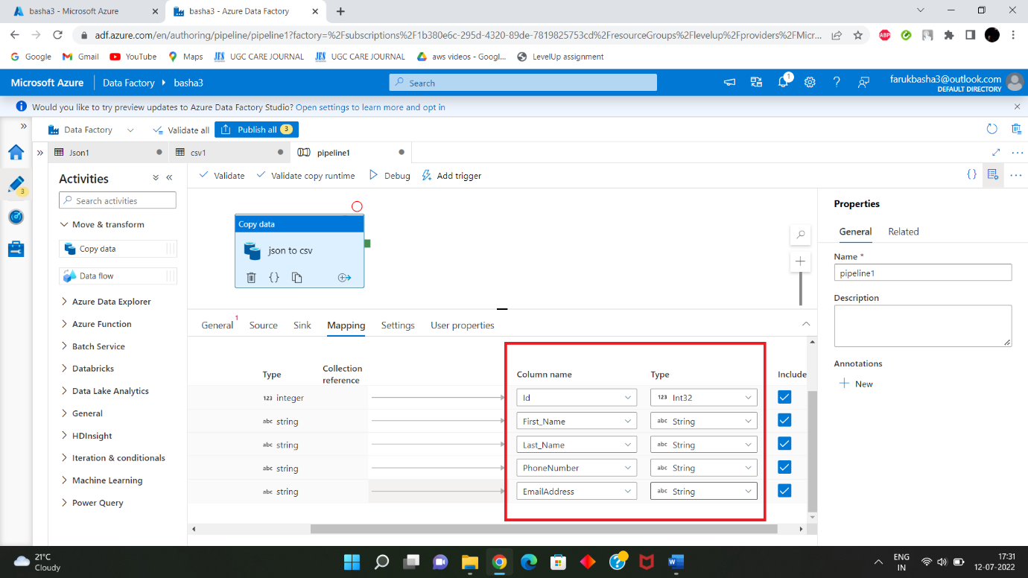

* Here you can change the column name and data types

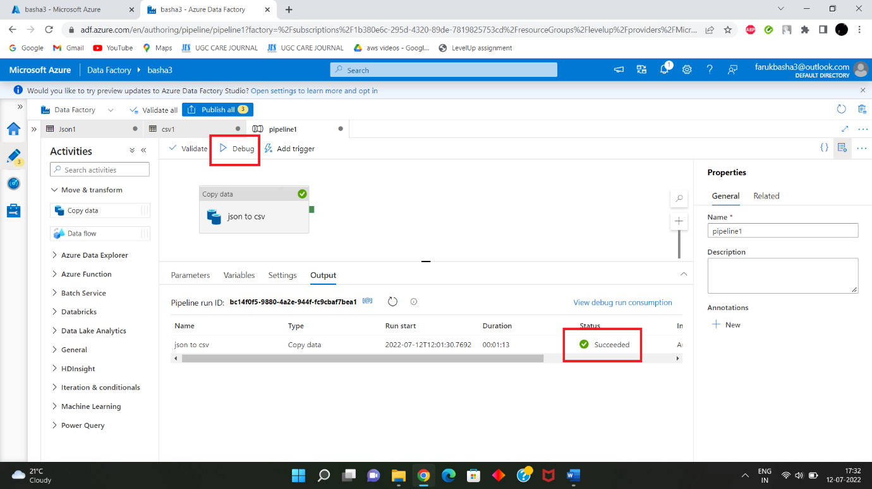

* Click on Debug after some time it will show Succeeded

**2.Copying CSV File to SQL Data base**

For copying CSV File into SQL Data base follow below steps:

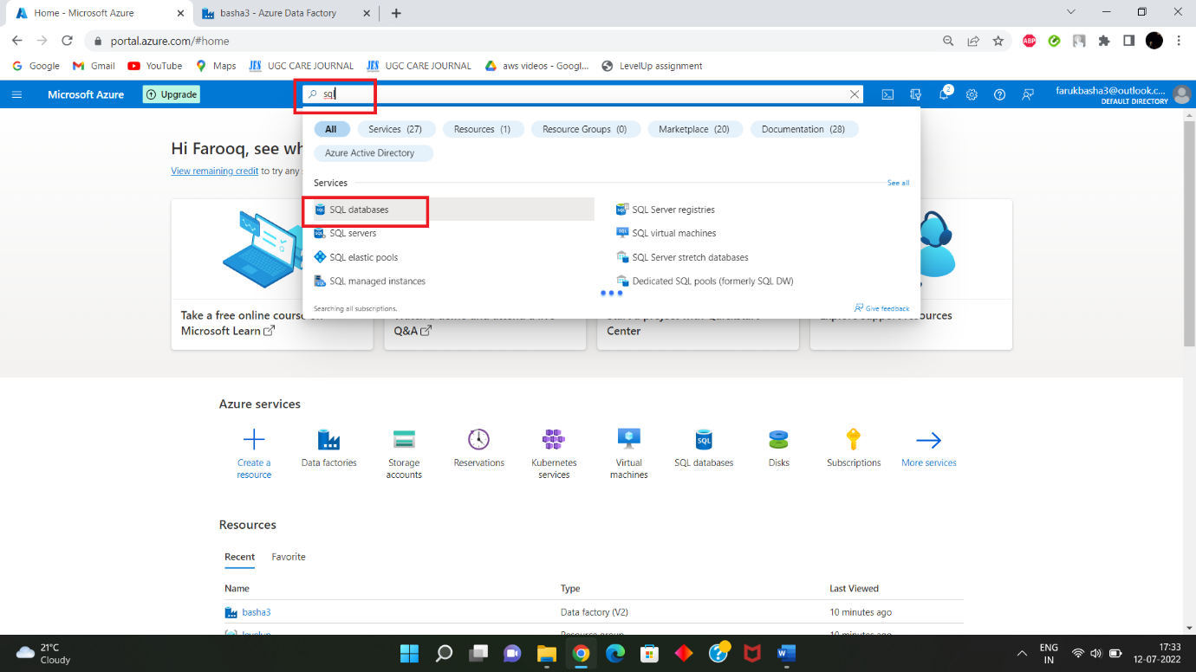

* Go to Search bar and type SQL database you can find that click on that

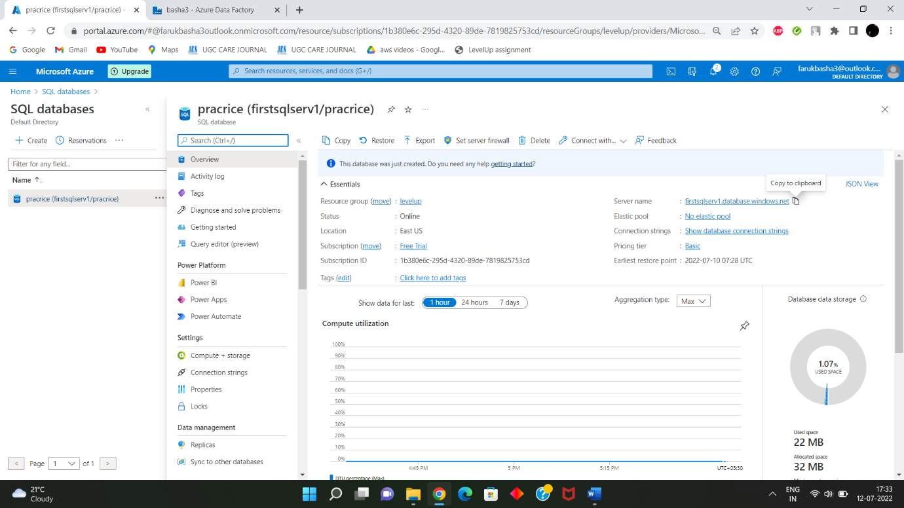

* Create SQL database after that the page looks like above figure

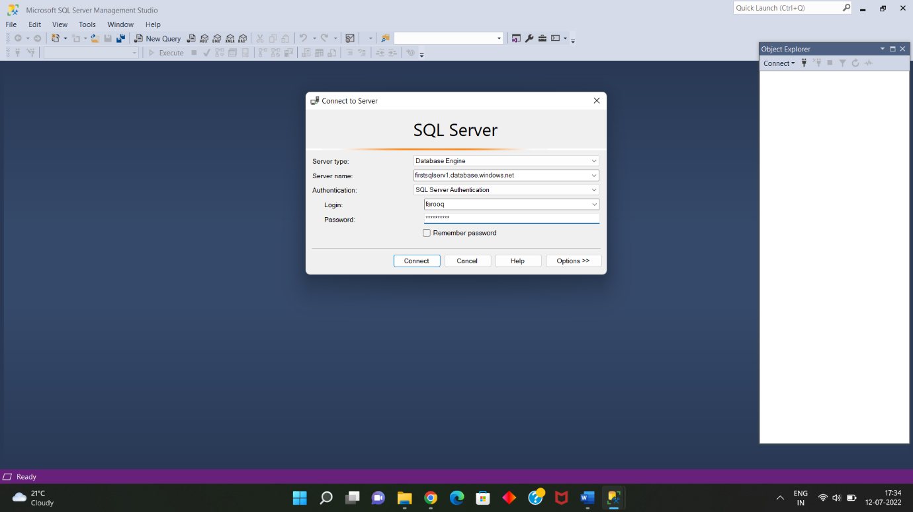

* Now Open Microsoft SQL Server Management studio
* Connect SQL server as when you give details in creation of SQL data base

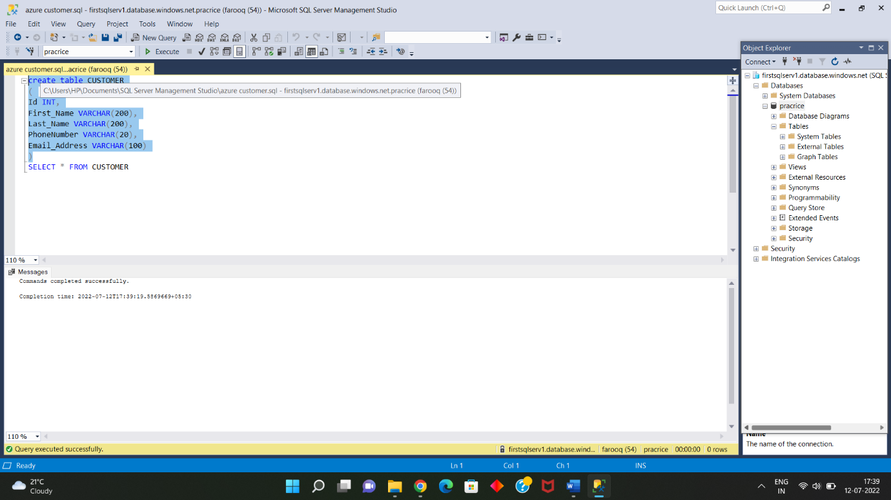

* Create a table as shown in above figure

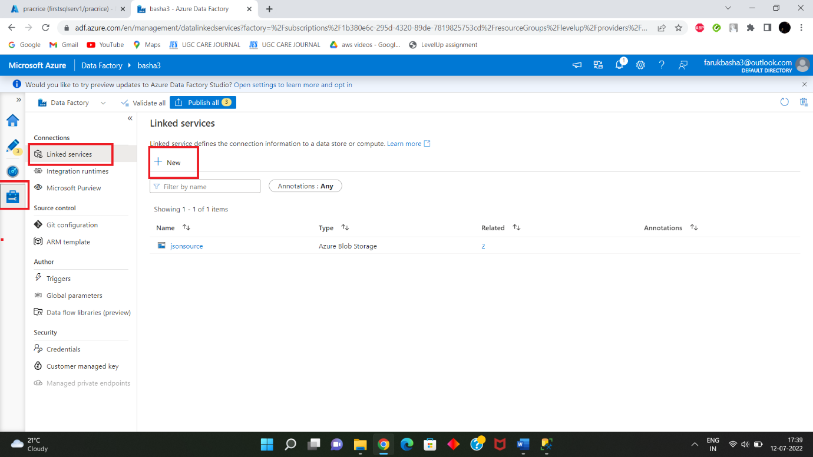

* Here we need to create another Linked service for SQL database
* For CSV We have already a linked service (jsonsource mine)
* Create new One

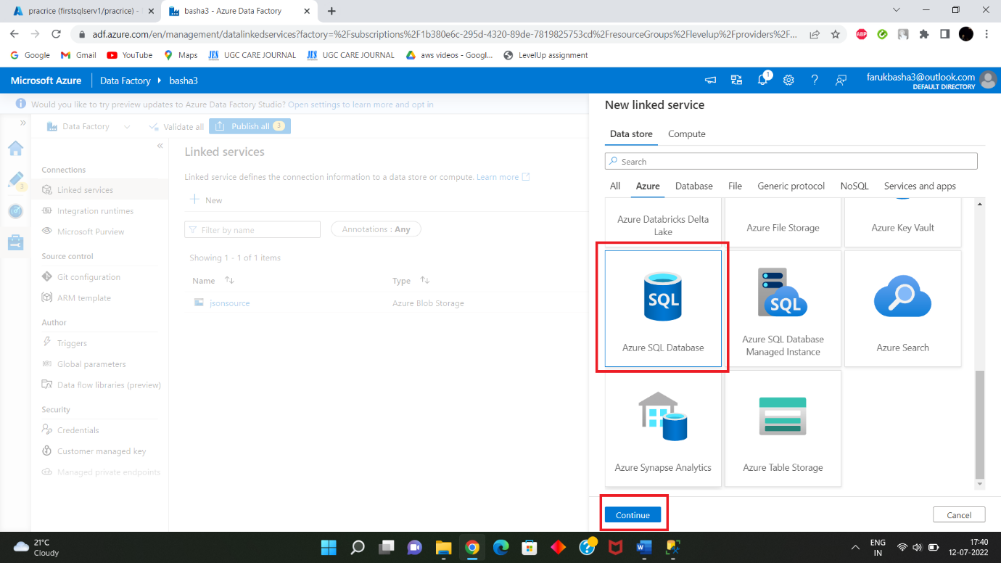

* Click On Azure SQL Database and Continue

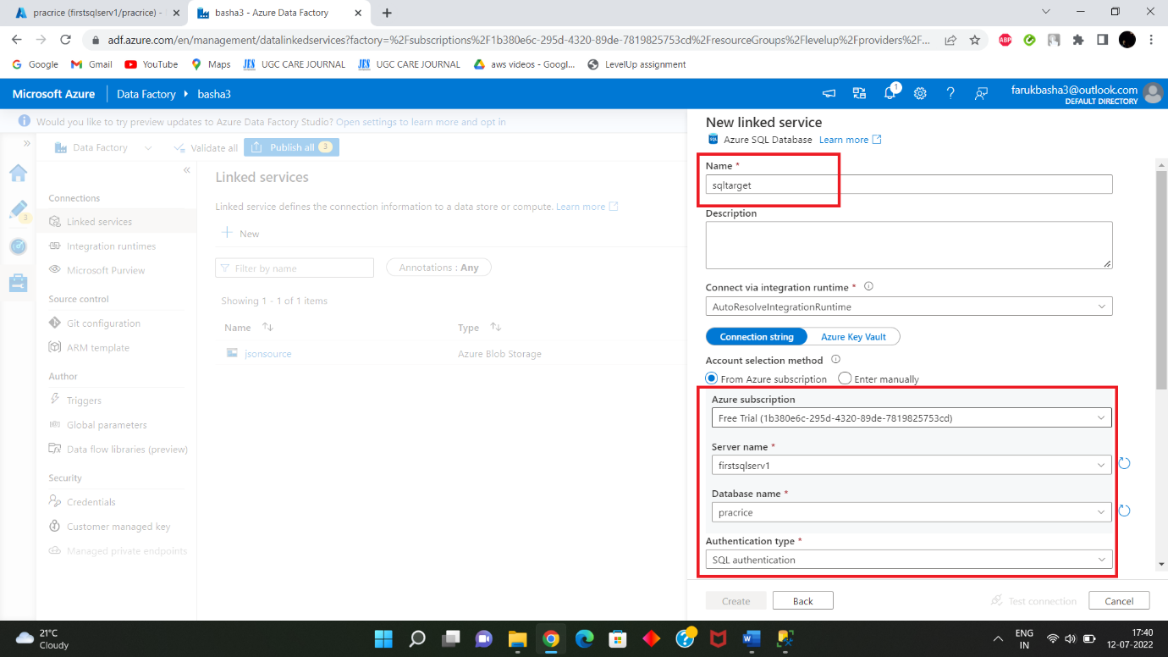

* Give a Name and fill all fields as shown in above figure

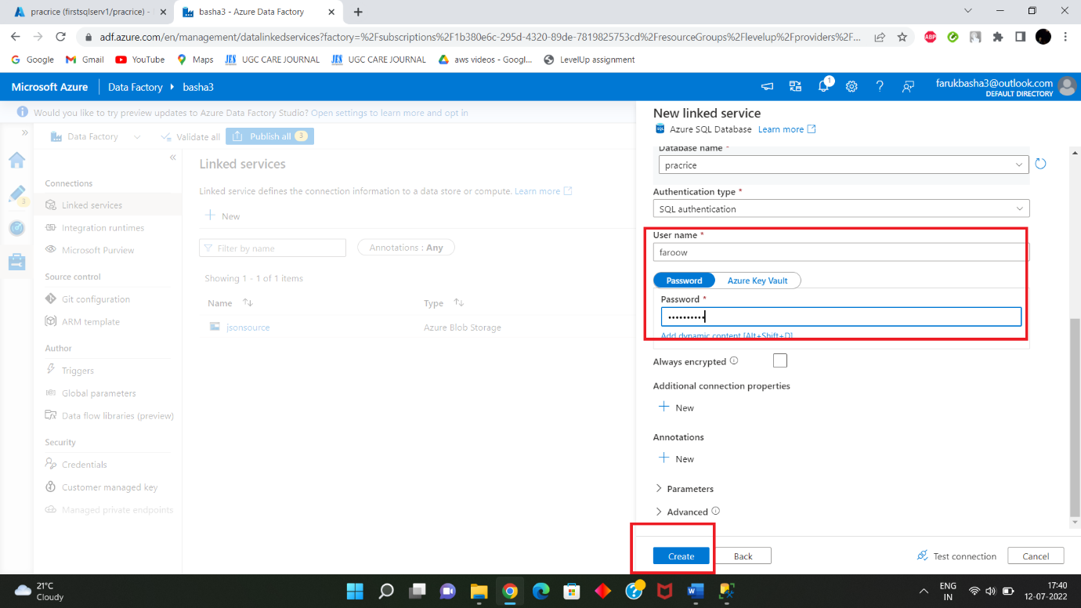

* Give a username and password when you gave in creation of SQL database and create

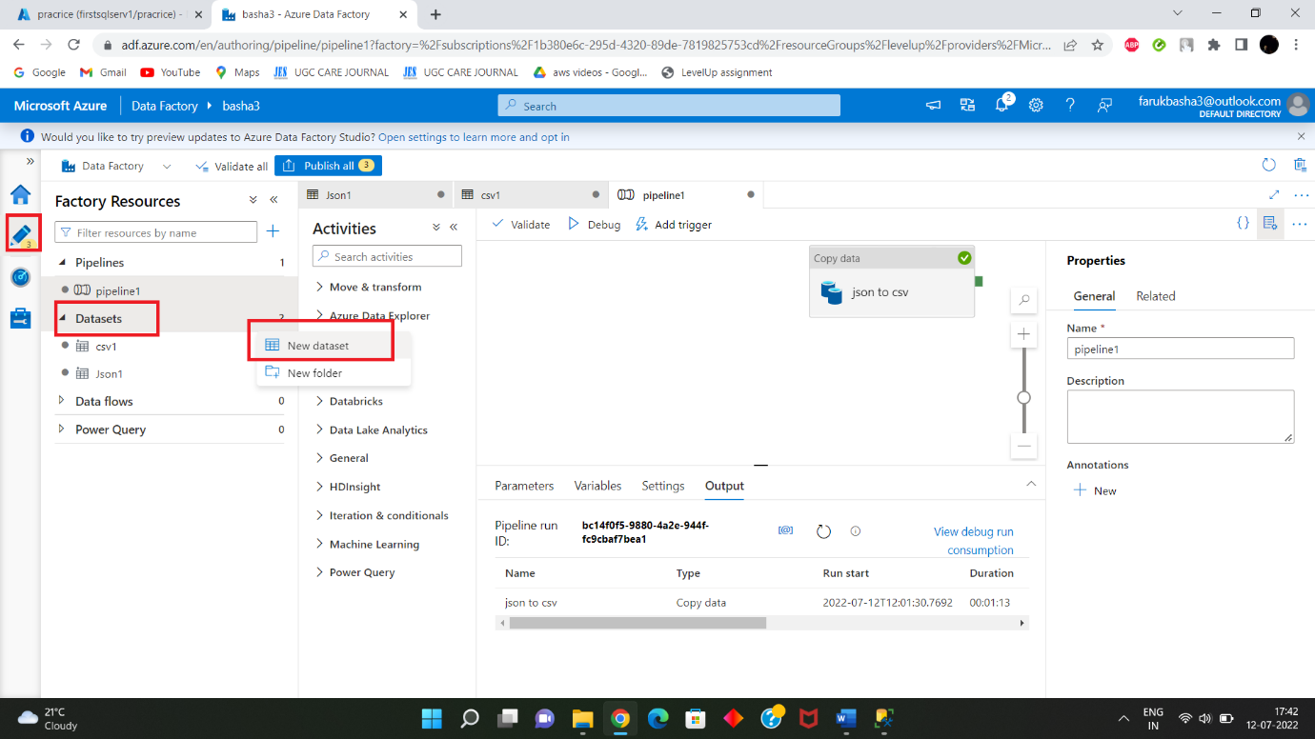

* After creation of Linked service, we need to create new dataset for SQL Database and for CSV we have already a dataset

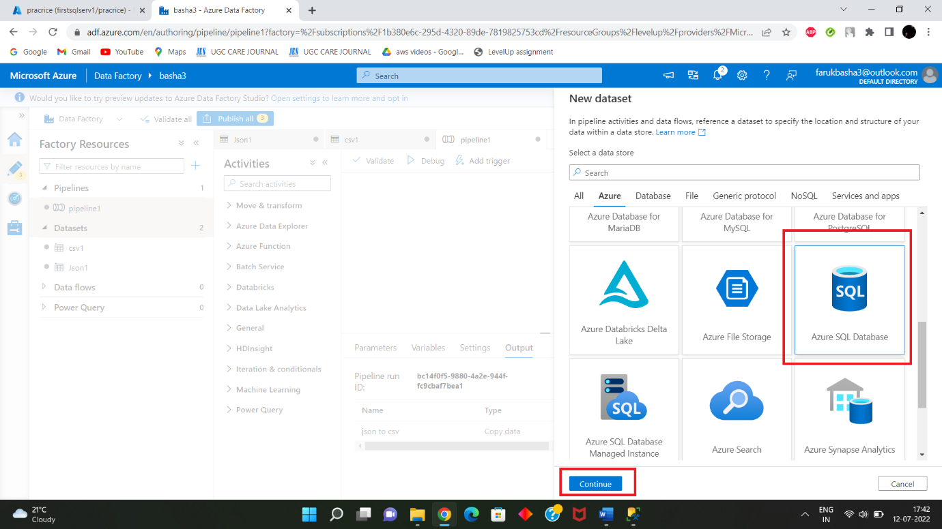

* In the datasets we need to select Azure SQL Database and click on continue

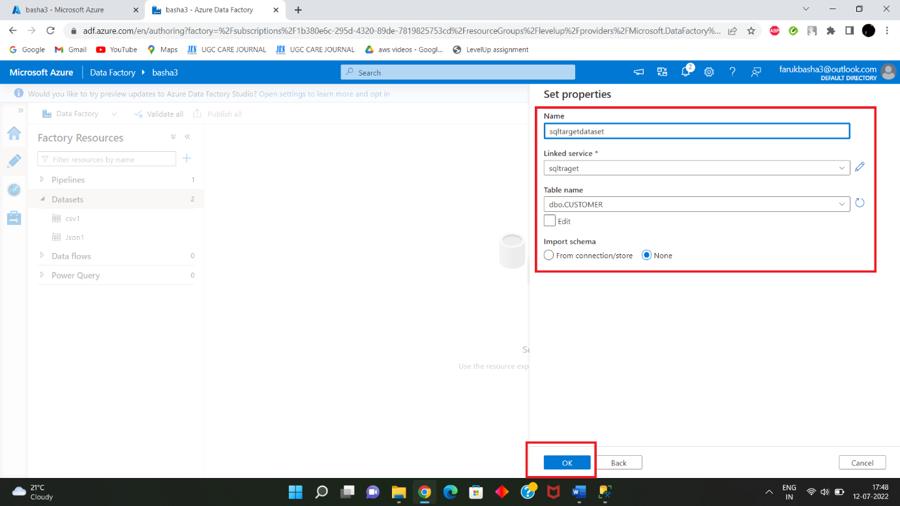

* In the properties Give a Name and Linked service link and Table name
* Select Import Schema “None”

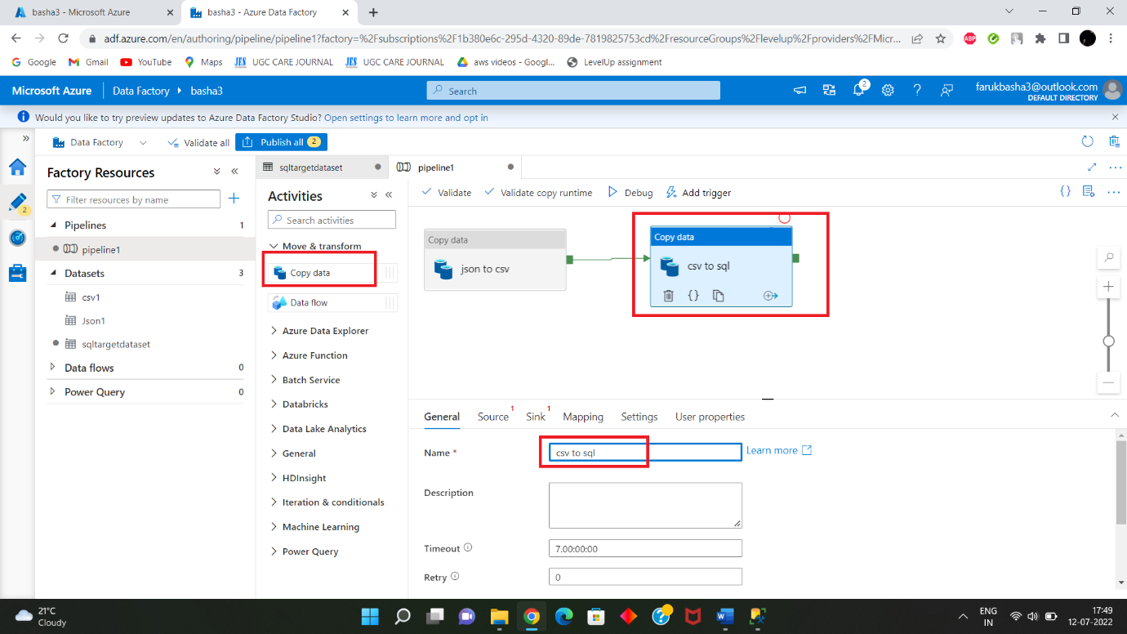

* Drag the copy data and join both copy data activities as shown in above figure

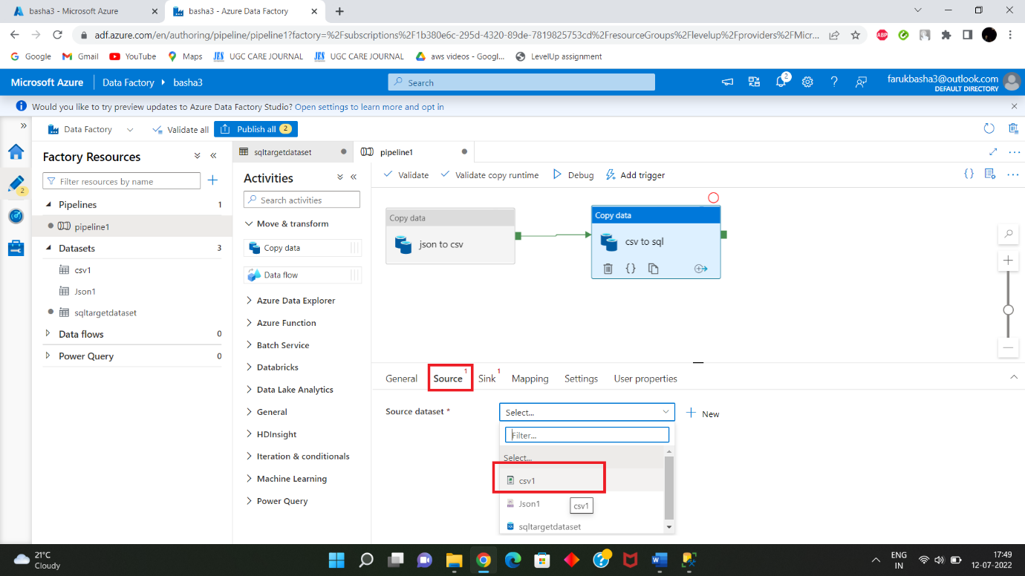

* In the Source select Target (csv1 mine)

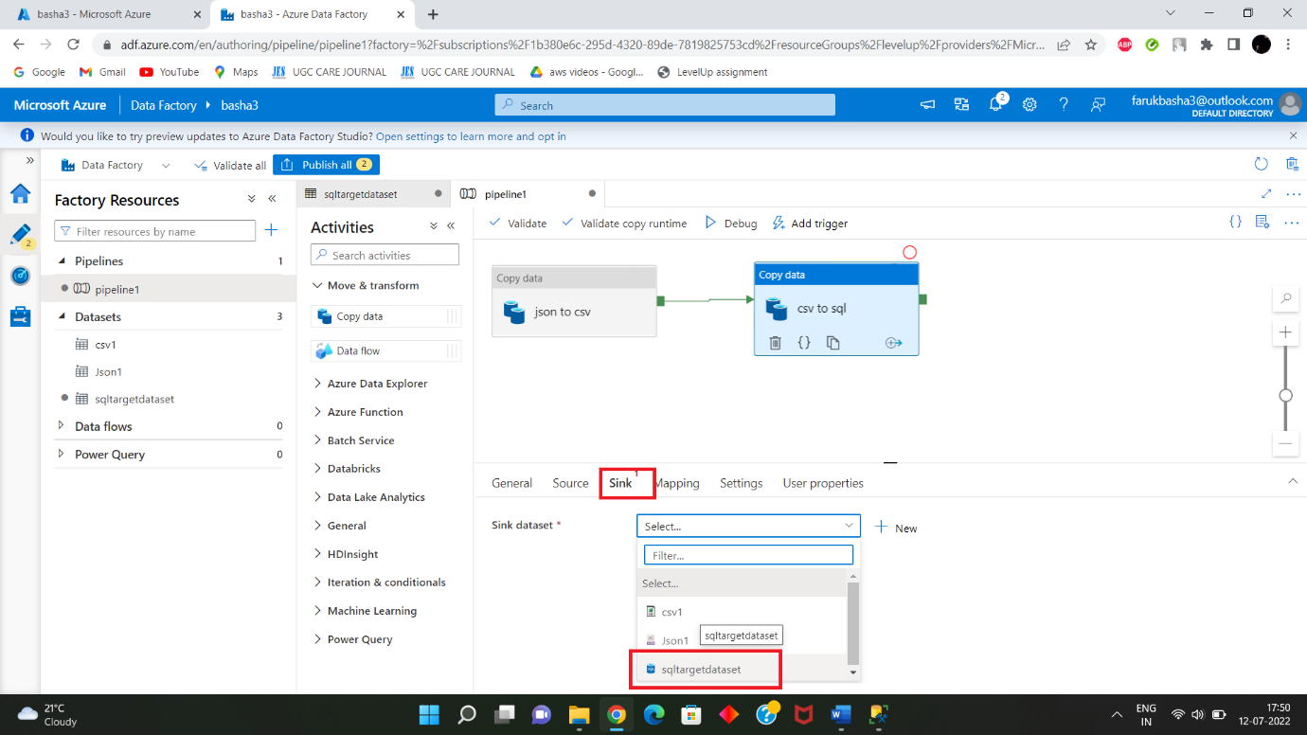

* In the sink select Sqltargetdataset

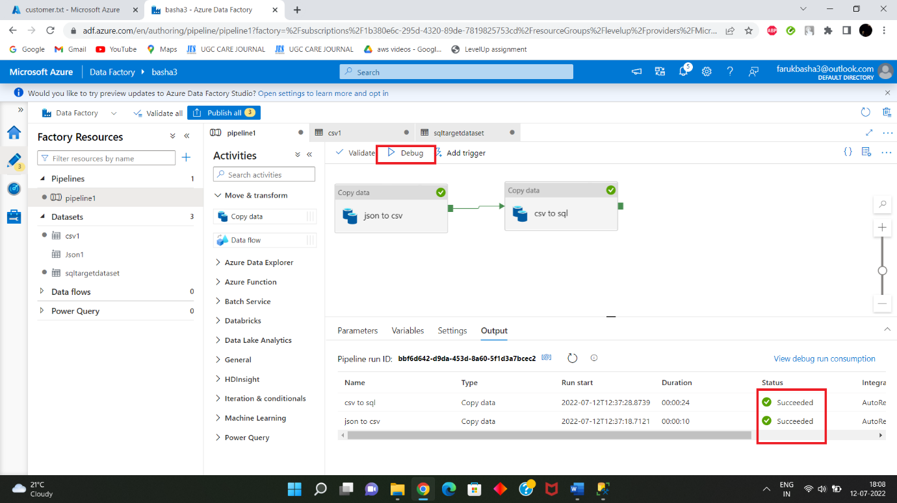

* Next, Debug after some time it will get succeeded

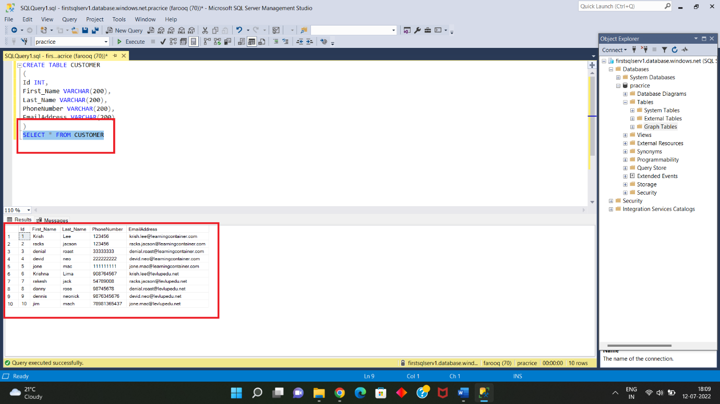

* After succeeded go to SQL and execute the statement than the results shown

**3.Copying JSON File to another BLOB Storage**

* For Copying JSON file to another blob storage, you need to create another storage account follow storage account creation steps as shown in copying json to csv

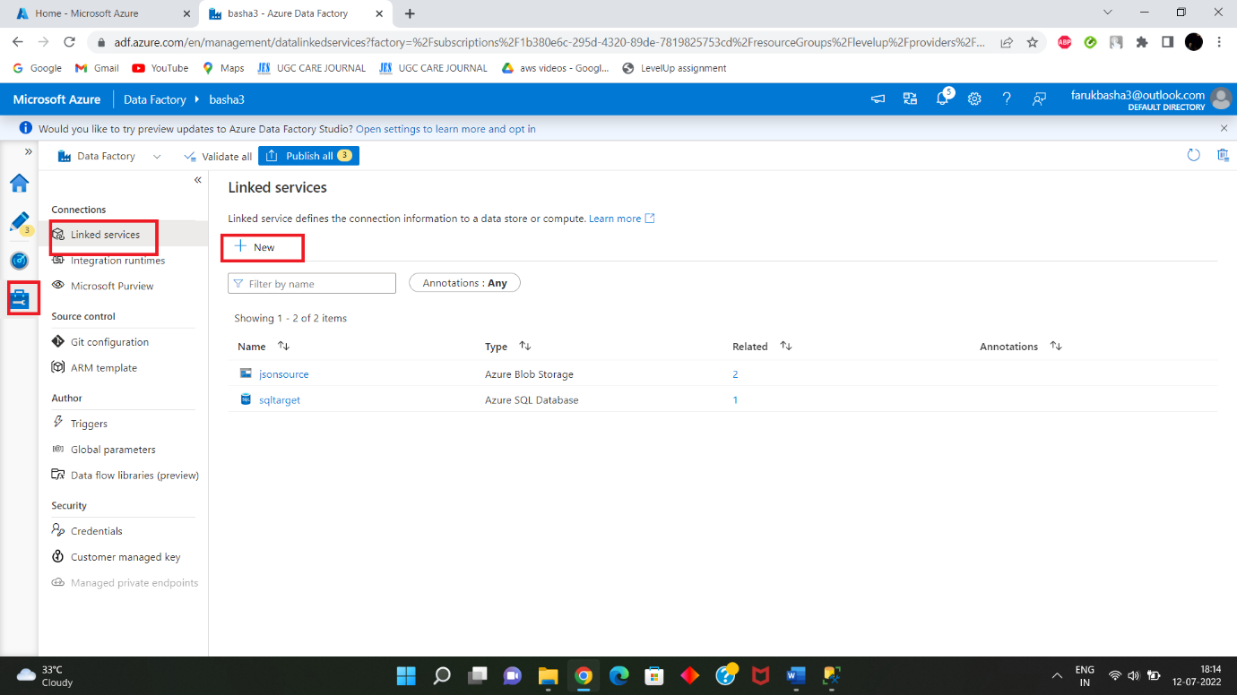

* After creation of Storage account and container you need to create Linked service for blob storage and we have linked service for json file.
* Create a New Linked service

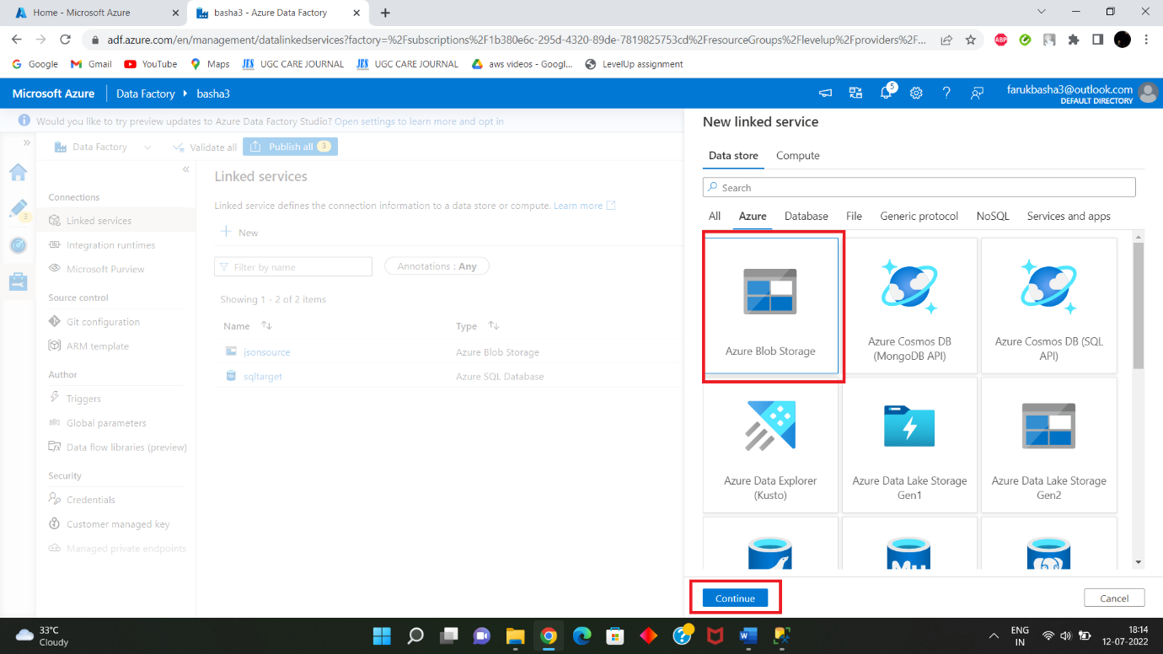

* Click On Azure Blob Storage and continue

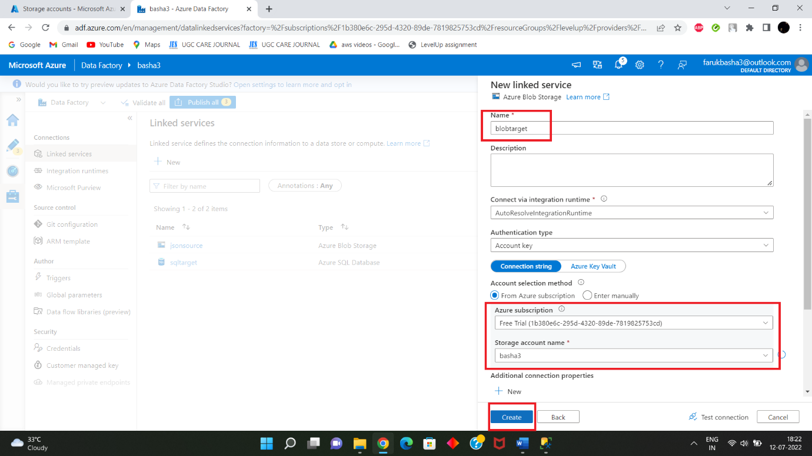

* Fill details as you require and create

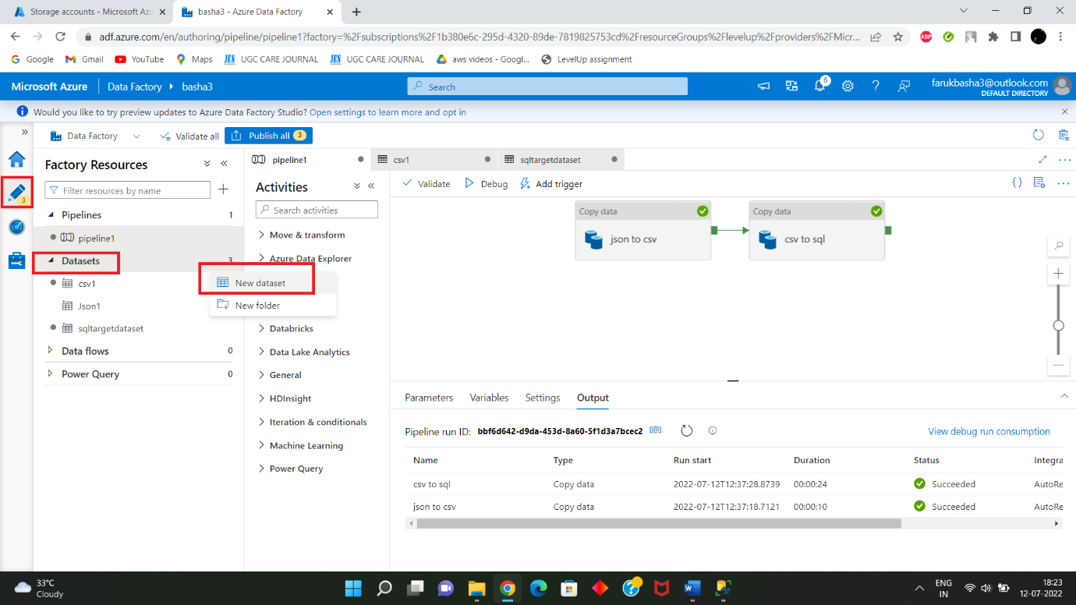

* Create a new dataset for Blob account

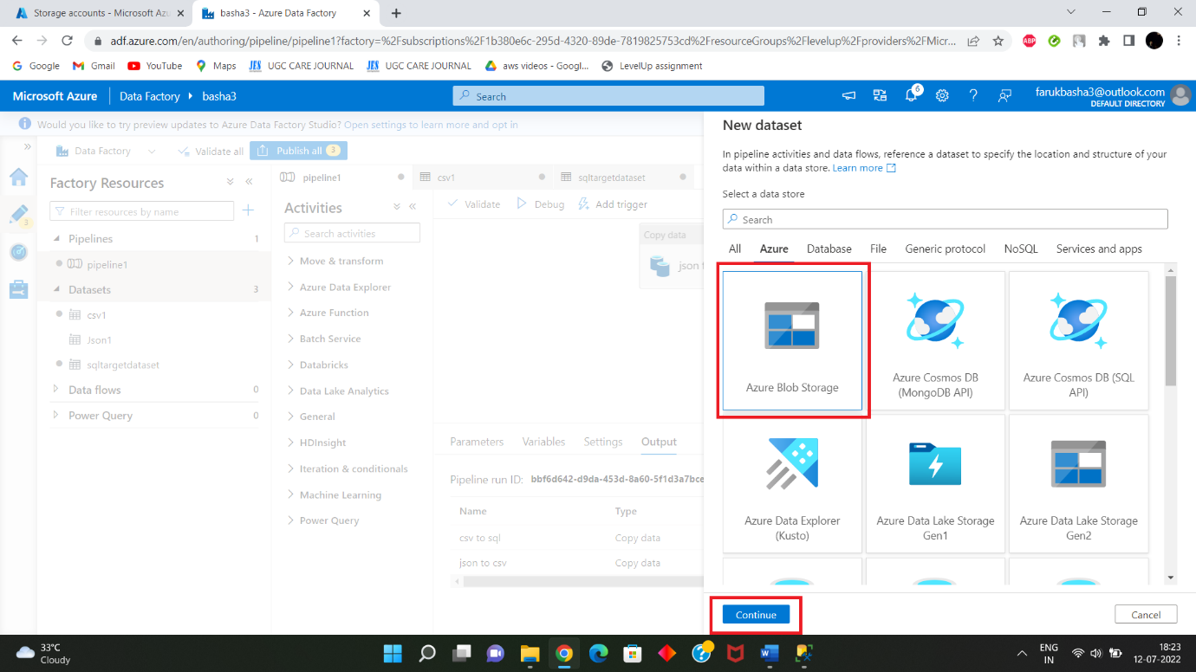

* Click on Azure blob storage

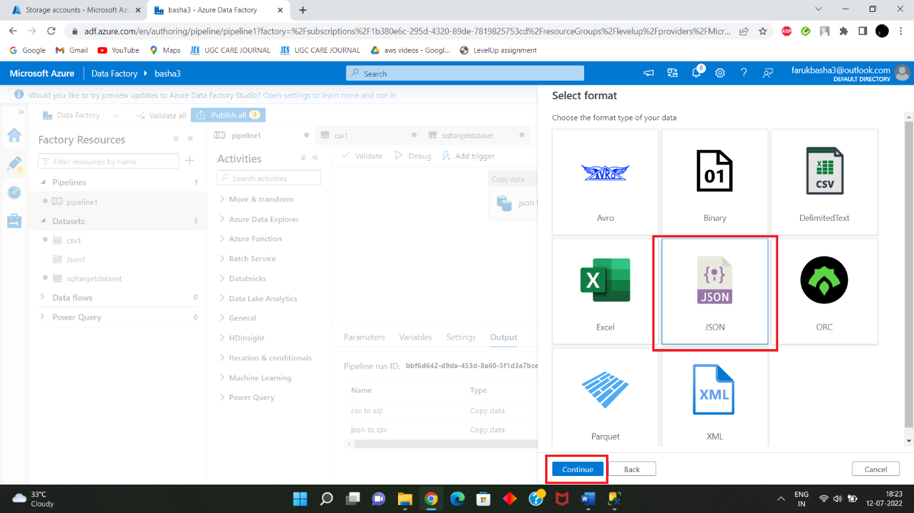

* Click on JSON file file format

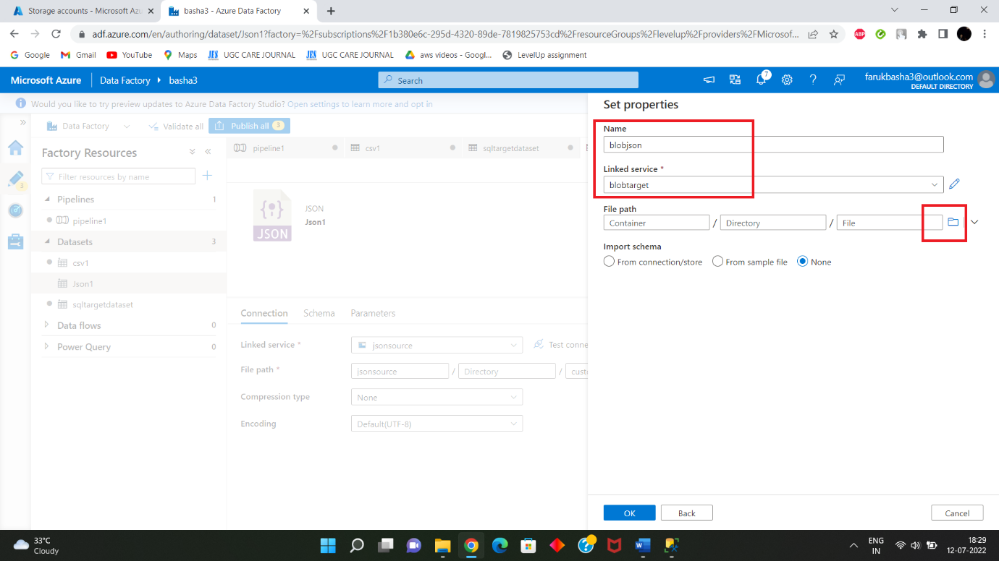

* Set properties give name and Linked service link
* Click On Browse

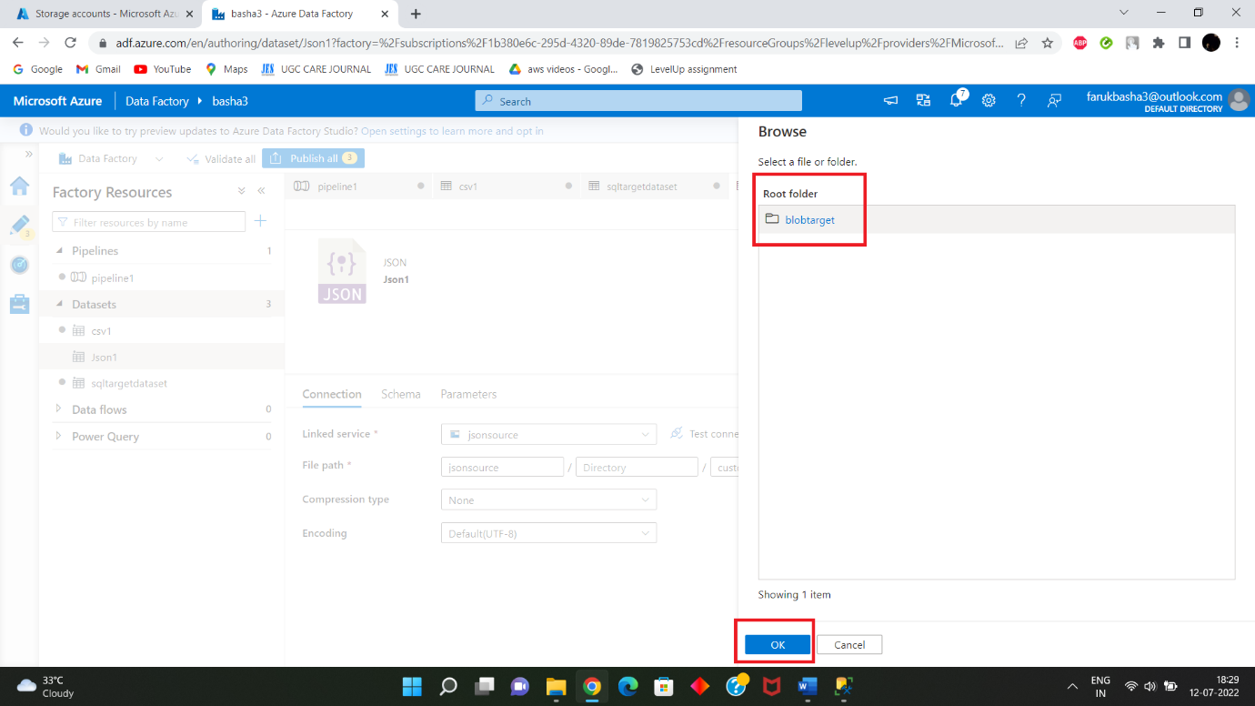

* In that Click on Blob target

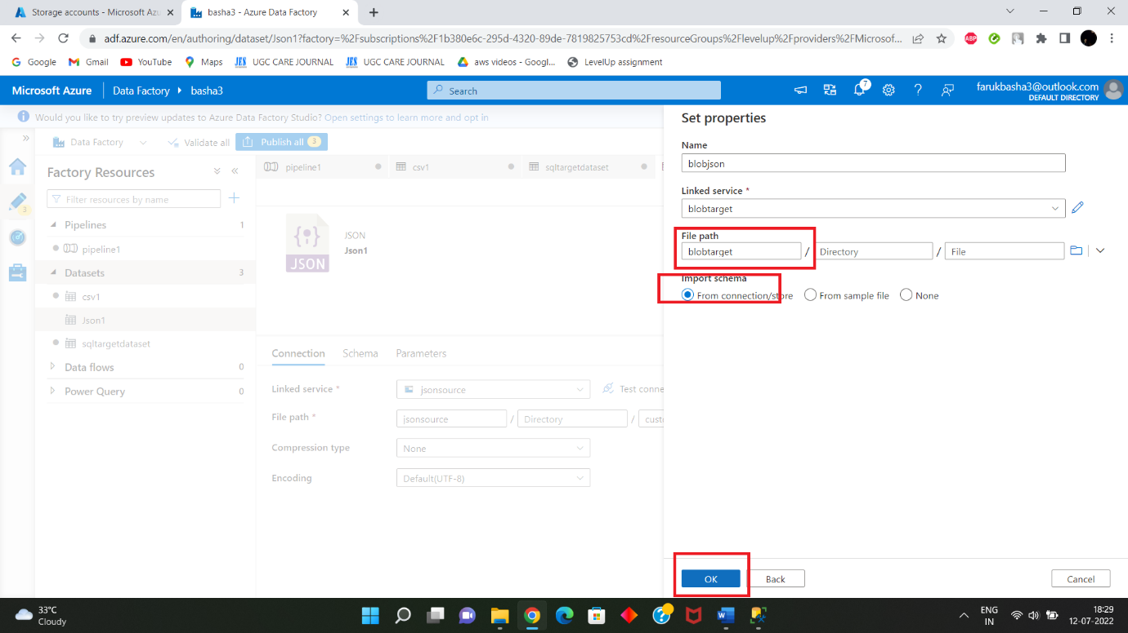

* After Selection of File path select Import schema and click ok

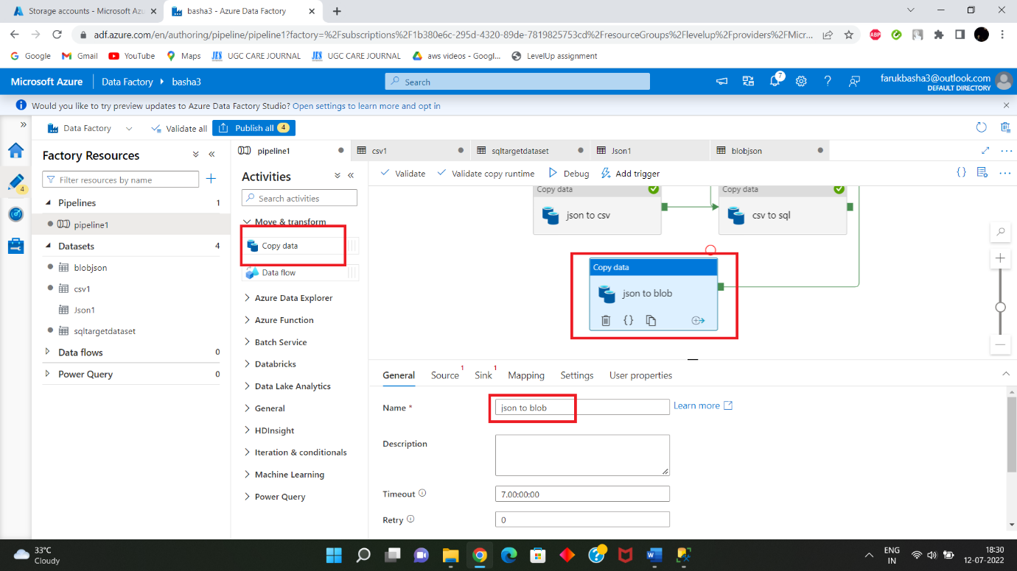

* Drag the copy activity and name it as json to blob link that to csv to sql copy file

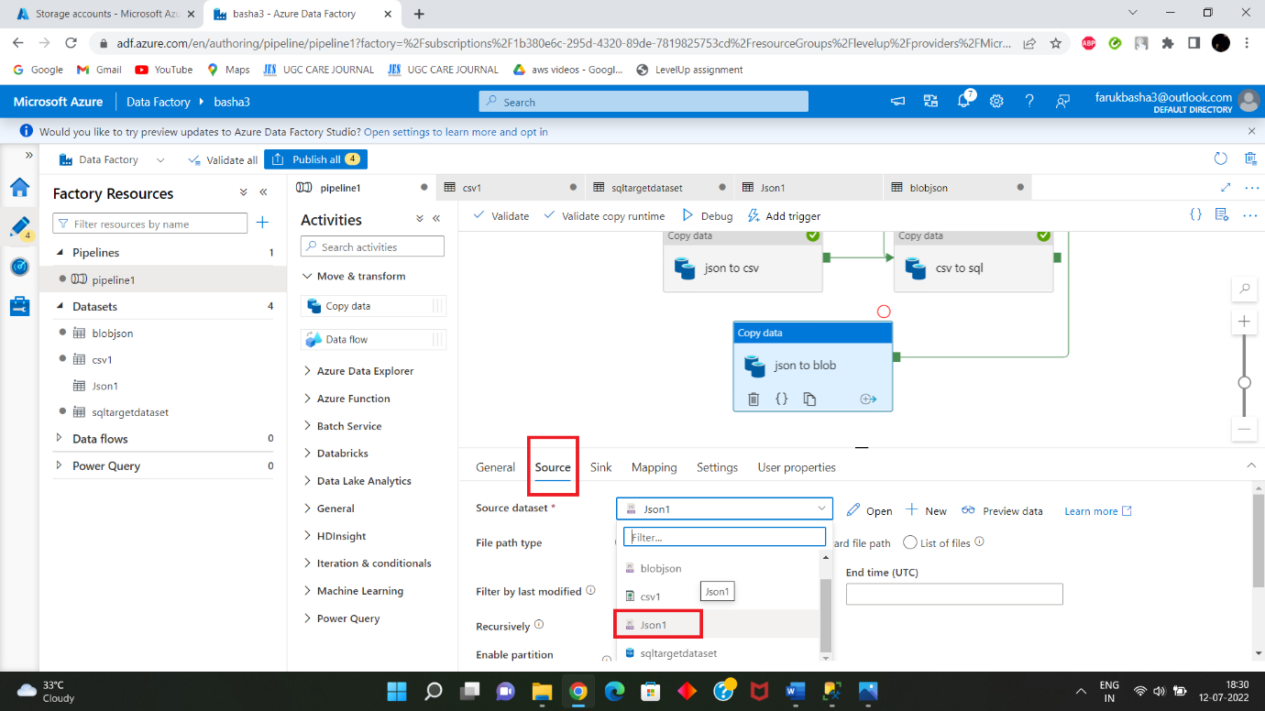

* In the source, select sourcedataset file (json mine)

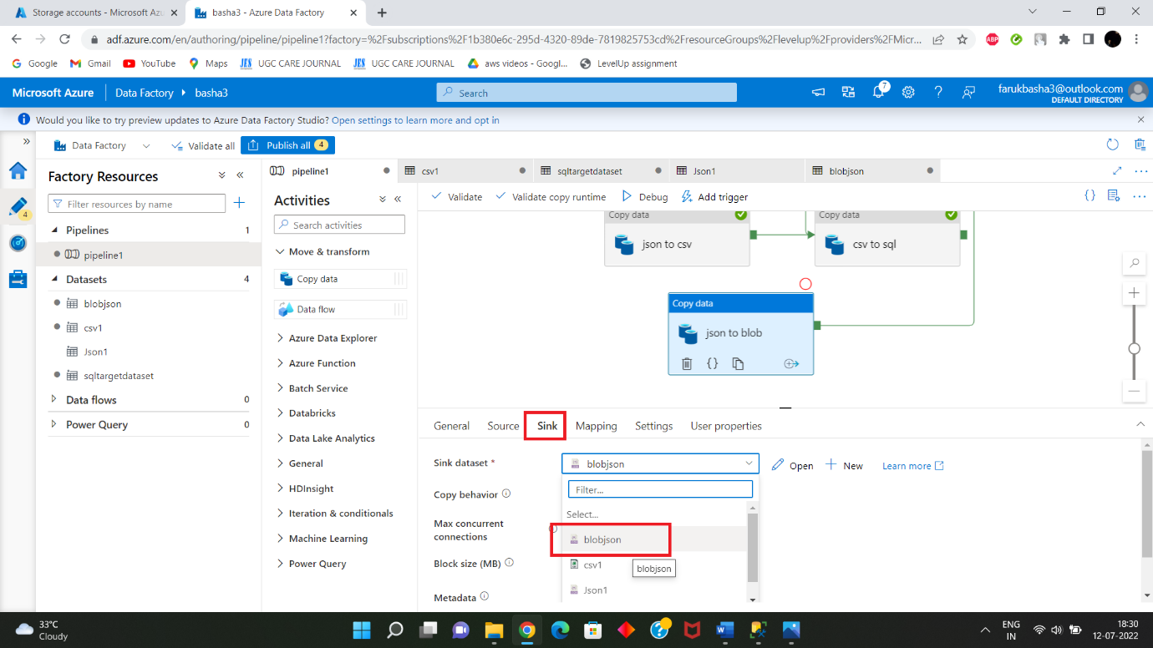

* In the Sink Select target dataset file

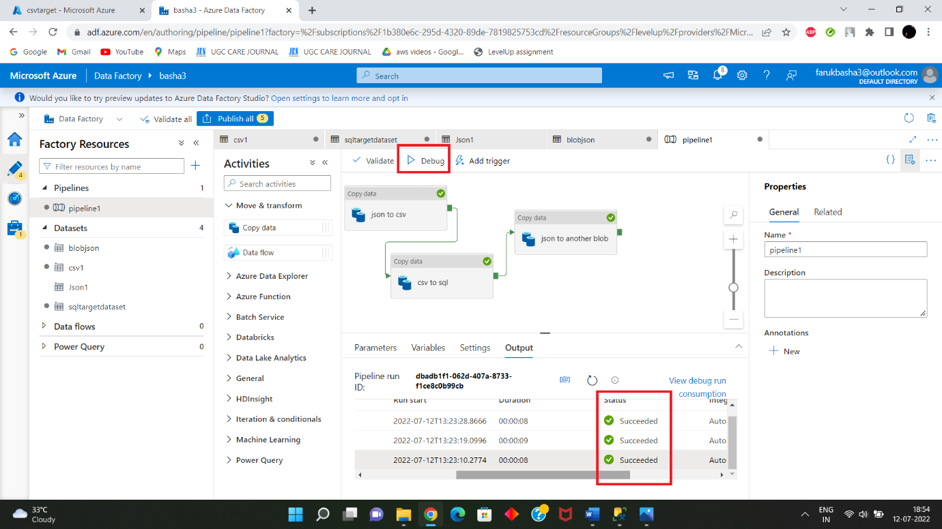

* Debug after some time it shows succeeded

**4.Delete JSON File from Source Blob**

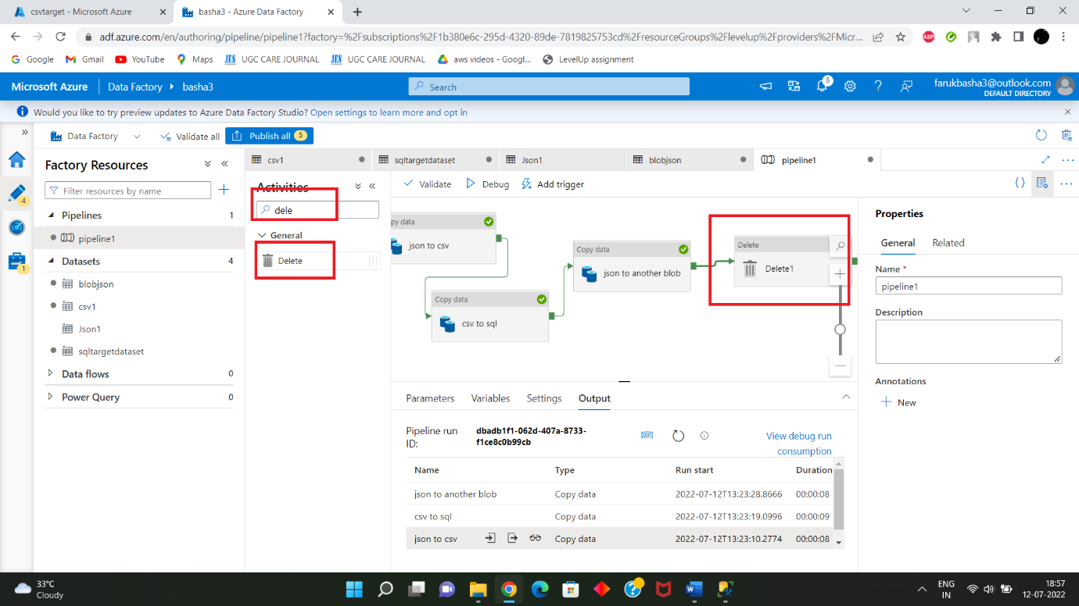

* Search Delete Activity and drag that and connects to json to blob copy activity

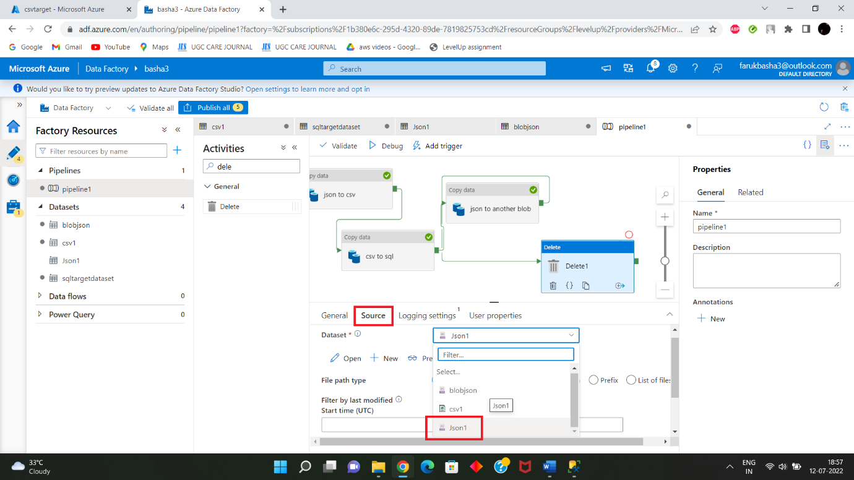

* In source select source dataset

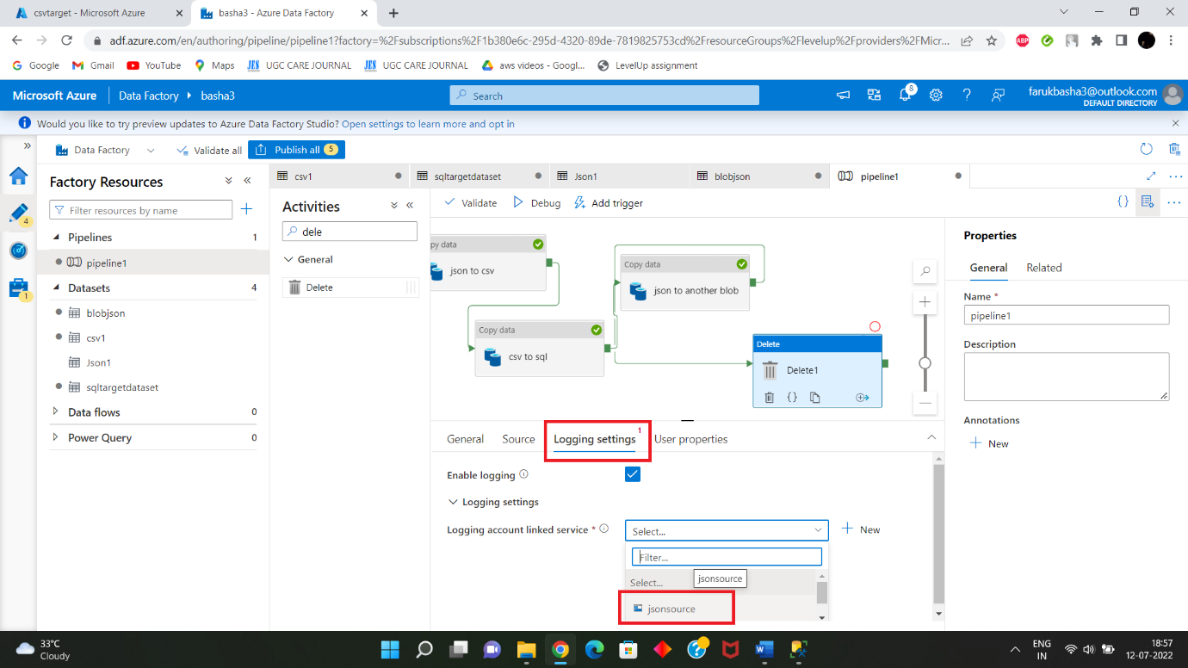

* Next, Select Logging settings in that select source linked service

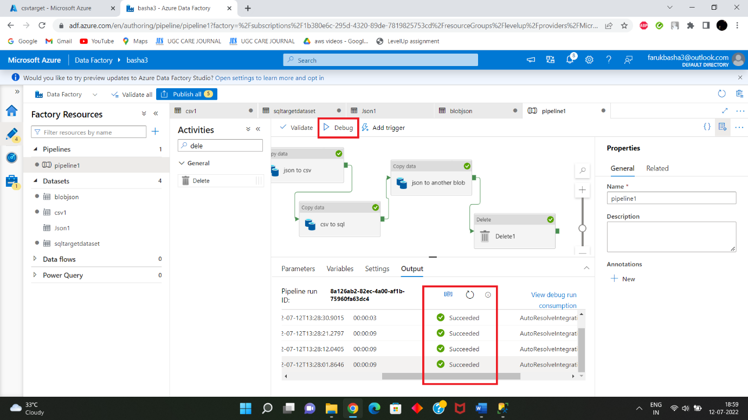

* Next Debug in a few minutes you will get Succeeded